George Emile Ory

August 22, 1882 – March 29, 1938

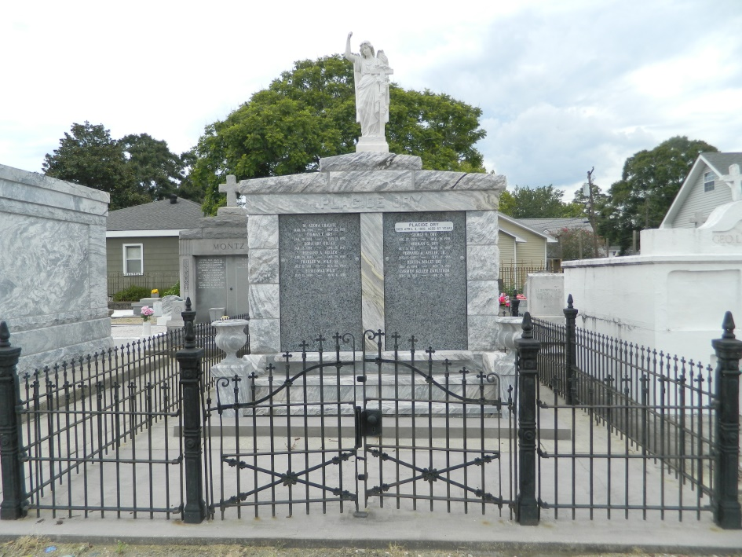

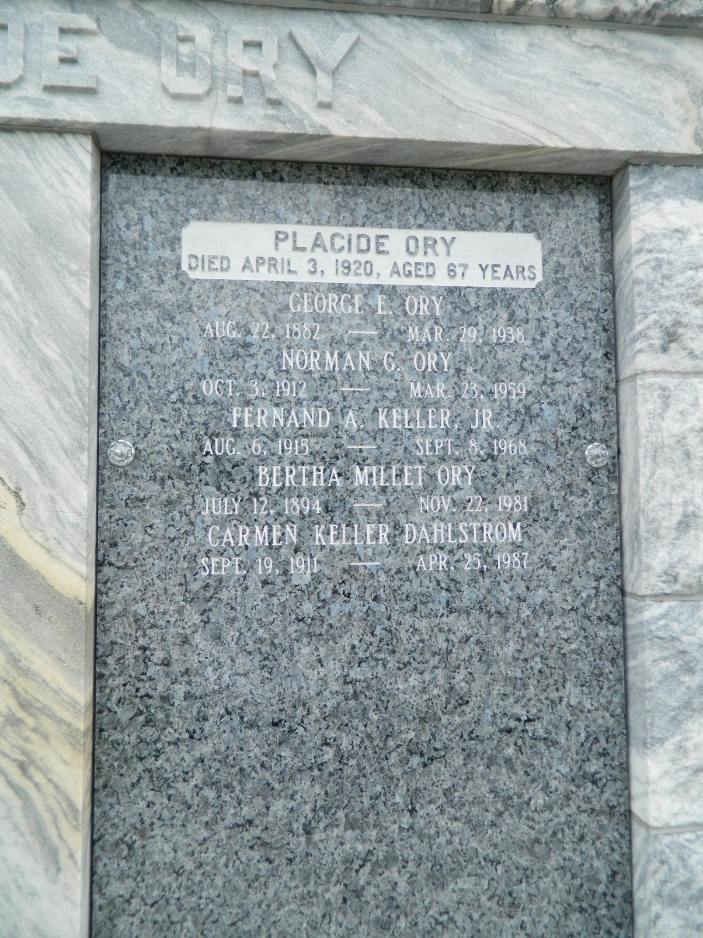

George E. Ory, 55, of Baker died this morning at 1:45 after an illnes of several months. He was a native of St. John the Baptist parish, but had lived in Baker for 27 years, where he was a farmer. His father was Placide Ory, prominent suger planter of St. John the Baptist parish. The body will be at Adams funeral home until 8 o'clock tomorrow morning when it will be taken to Reserve. Services will be held at 10:00 at St. Peters church, Father Eyraud officiating. Burial will be in St. Peters cemetary. Surviving are his widow; five sons, Norman, Reginald, George, Earl, Virgil and Albert Ary (sic); and four daughters, Marjorie, Gloria, Carol and Yvonne Ory.

Newspaper clipping, unknown paper