Dr. Oscar Joseph Ory

November 16, 1885 – April 18, 1954

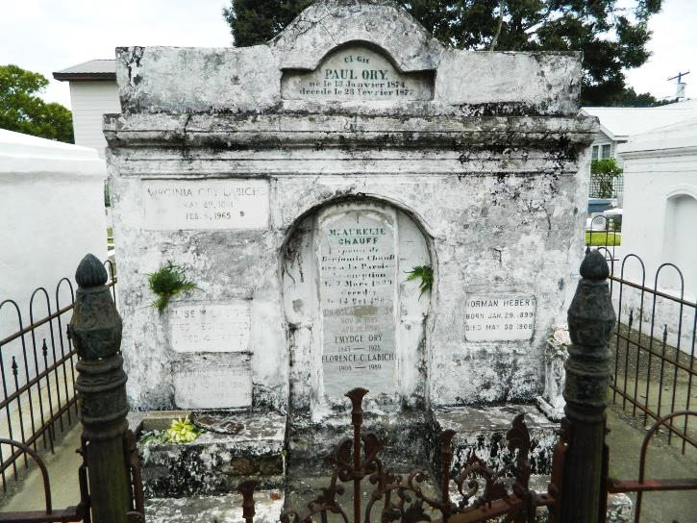 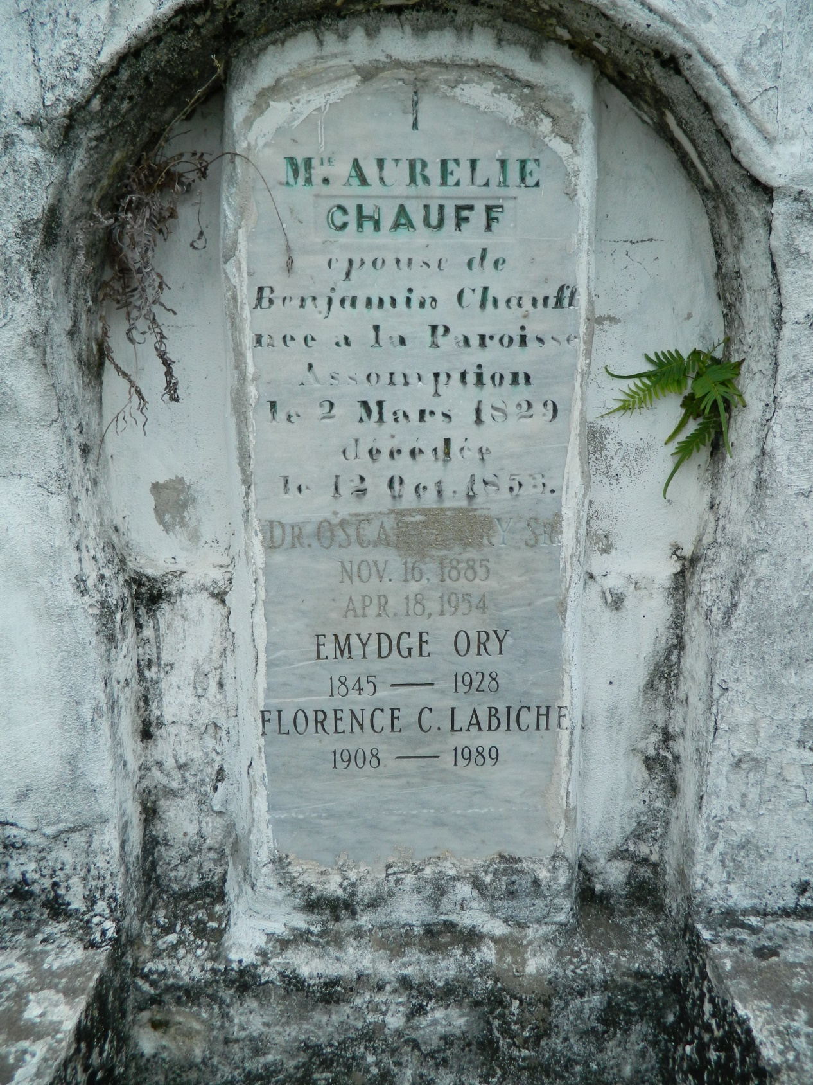

Ory, Dr. Oscar J. Sr. died at 7:15 pm Sunday at Our Lady of the Lake Hospital after an illness of two weeks. Born Nov. 16, 1885 in Sunshine, Iberville Parish, he was 68 year old and a resident of Garyville. The son of the late Emygde and Aurelia Shauffe (sic) Ory, he was a member of St. Hubert's Catholic Church in Garyville and of the Knights of Columbus. Was treasurer of the Louisisana State Dental Association for some 40 years and was past president of the group. Graduated from Vanderbilt University in 1906 and was a member of Delta Sigma Delta Dental fraternity and a member of the International College of Dentists and the American Dental Association. Survived by his wife the former Beatrice Richard of Sunshine; two sons, Richard of Garyville and Dr. O. J. Ory Jr. of Laplace; one daughter, Mrs. Lawrence Uter of Baton Rouge and one sister, Mrs. S. H. Labiche of Lions and seven grandchildren. Body to rest at Millet's Funeral Home in Reserve. Funeral services to be held at 9:30 am Tuesday at St. Hubert's Catholic Church in Garyville, with burial in the Catholic cemetery in Reserve. The Rev. Weiss is to officiate.

Baton Rouge Advocate (LA) on 4/19/1954, p. 6a