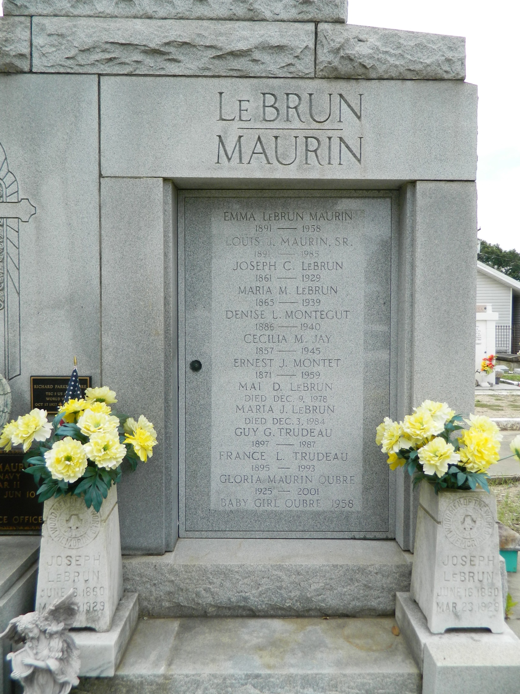

Gloria Mae Maurin Oubre, 76, a native and resident of Reserve, died May 24. She was the wife of Richard Parker Oubre and mother of Richard "Derf," Oren, Giselle, Louis and the late Baby Girl Oubre. She was also the daughter of the late Louis Sr. and Emma LeBrun Maurin and sister of Marjorie McTopy, Elaine Delaneuville, Marie Montz, JoAnn Montz, Louis Maurin Jr. and the late Joseph Maurin. She is also survived by six grandchildren. Services are today at noon at St. Peter Catholic Church, Reserve, with interment at the church cemetery. Visitation starts at 9 a.m.

**L'Observateur (La Place, LA) - Saturday, May 26, 2001**

**Contributed by Jane Edson**