Josephine (Haydel) Oubre

March 19, 1916 – December 28, 2004

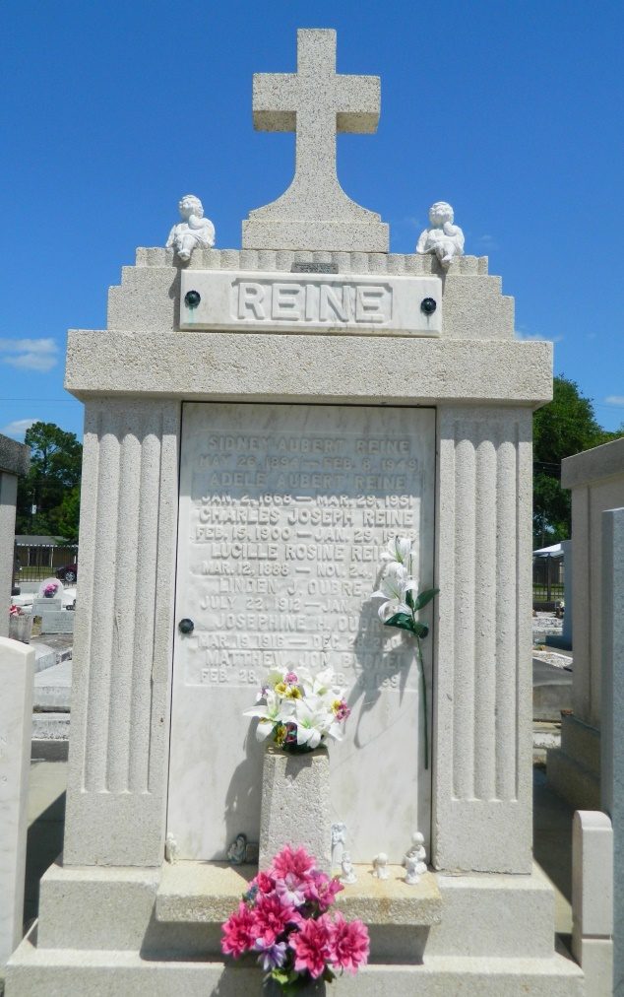 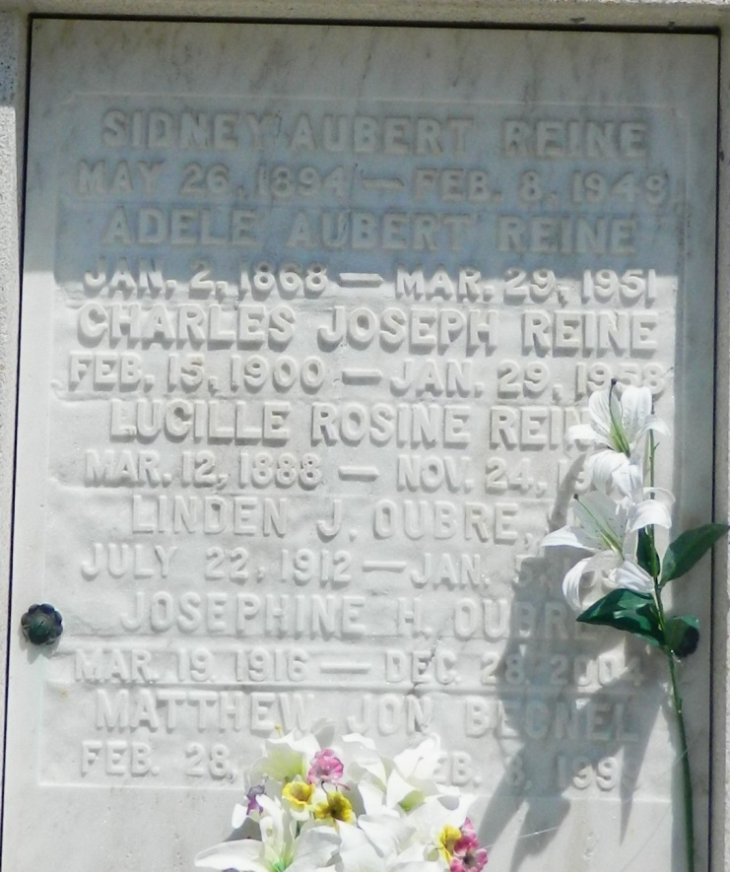

RESERVE - Josephine Haydel Oubre, 88, a native of Darrow and resident of Reserve, died Dec. 28. She was the wife of the late Linden "Bilbo" Oubre Sr., and mother of Cheryl Triche, Mary Ann Becnel and Linden Oubre Jr.  
 She was also the daughter of the late Dixon Sr., and Madeline Kramer Haydel, and sister of Agatha Dempster, Philomene Babin, and the late Adele Haydel, Anita Clement, Marie Boudreaux, Lillian Chartain, Joseph, Dixon Jr., Valcour, Winton, Agnes, Cornelia and Jean Haydel.  
 She is also survived by 12 grandchildren, 19 great-grandchildren and one great-great-grandchild. She is preceded in death by one grandchild and one great-grandchild.  
 Services were Dec. 30 at St. Peter Catholic Church, Reserve, with interment at the church cemetery.

L'Observateur (La Place, LA) - Tuesday, January 4, 2005

Contributed by Jane Edson