Shannon (Swisher) Patterson

April 21, 1969 – December 24, 2012

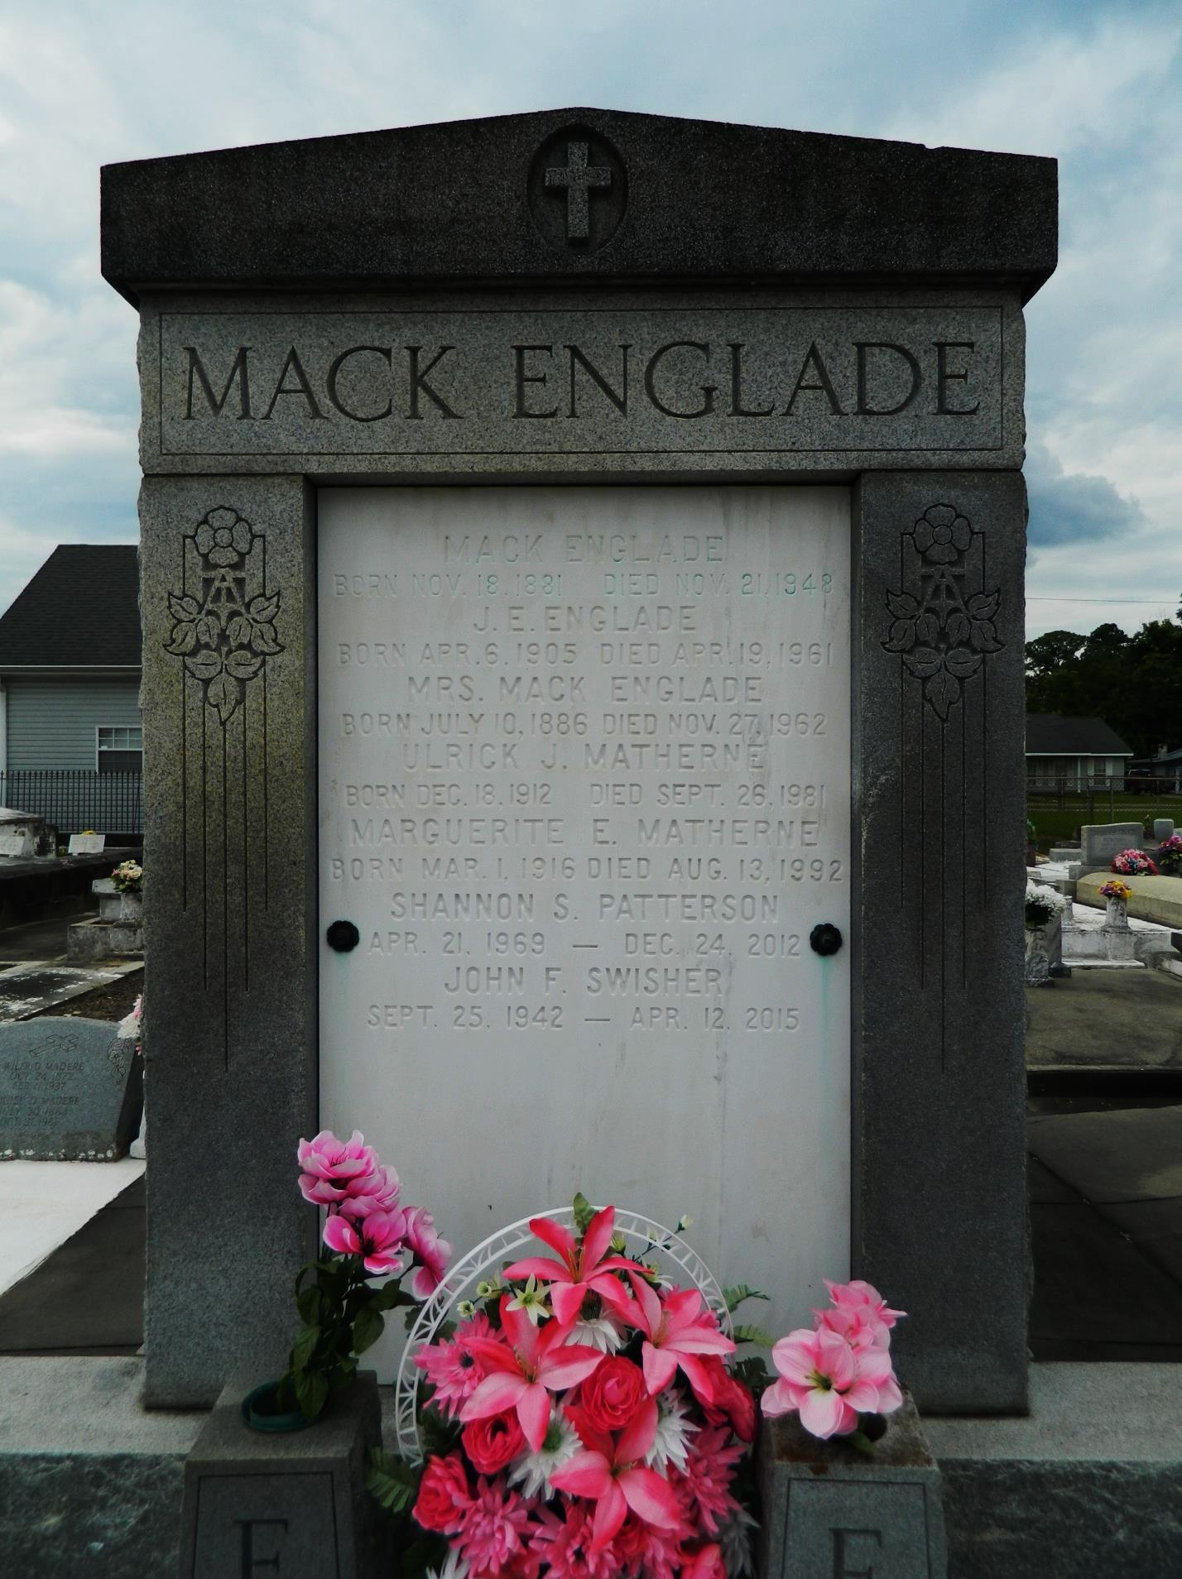

Shannon Swisher Patterson, age 43, was born on April 21, 1969 and passed away on December 24, 2012. She was a native of Lutcher and a resident of Gramercy. She is survived by her husband, Mark Patterson; her children: Emily C., Emily A, Lillian, Jacqueline, Kathleen, Wesley, and Mark A. Patterson. She is also survived by her parents: John Swisher and Kathleen Matherne Swisher; her brothers: Vince and Johnny Swisher; and her sisters: Patricia S. Loupe and Natalie S. Reeves; as well as her nieces and nephews: Lindsey Montz, George Loupe, Kaitlyn Loupe, Madison Reeves, Mikey Reeves, Olivia Reeves, Kamryn Montz and Clayton Montz.

Visitation will be on Friday, December 28, 2012 from 6:00 p.m. until 9:00 p.m. at First Baptist Church, 1046 N. Airline Ave., Gramercy, LA, and will resume at the Church on Saturday, December 29, 2012 from 9:00 a.m. until 11:00 a.m. followed by religious services at 11:00 a.m. Burial will be in St. Peter Cemetery, Reserve, LA. ROSE LYNN FUNERAL SERVICES is in charge of the arrangements. To sign and view the family guestbook, please visit [www.roselynnfuneralhome.com](http://www.roselynnfuneralhome.com/). In lieu of flowers, please make donations to the Shannon Swisher Patterson Memorial Fund at any First American Bank.

**Advocate, The (Baton Rouge, LA) — Thursday, December 27, 2012**

**Contributed by Jane Edson**