Gloria (Keller) Perilloux

June 21, 1928 – June 19, 1972

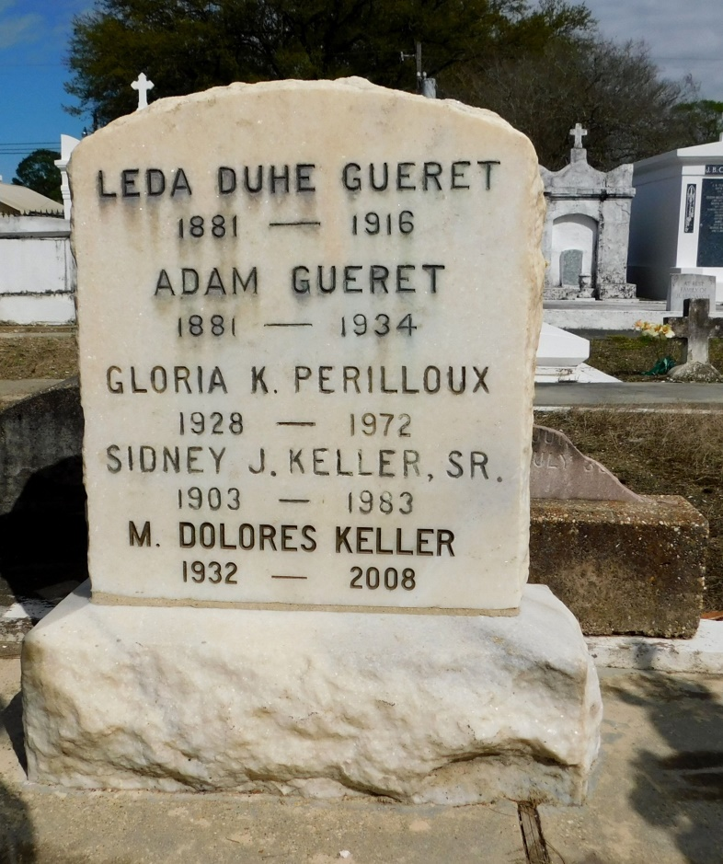

Photo by Mary Agnes Hammett

Gloria Keller Perilloux, a native and resident of Reserve, Louisiana, died Monday, 19 Jun 1972 at age 44 years. She was the daughter of Mr. and Mrs. Sidney Keller Sr. and the mother of Keith and Kevin Perilloux. She was the sister of Sidney J, Mrs. Leslie (Theresa) Vicknair, Dolores, Jean, Morgan and Gerald Keller, all of Reserve. Services were Wednesday 21 Jun 1972 at St Peter Church, Reserve, with interment in St Peter Cemetery, Reserve.

From Obituary, The Times-Picayune, New Orleans, LA; 20 Jun 1972

Contributed by Dwayne Montz