Ray Charles Prejean

August 23, 1930 – May 2, 2004

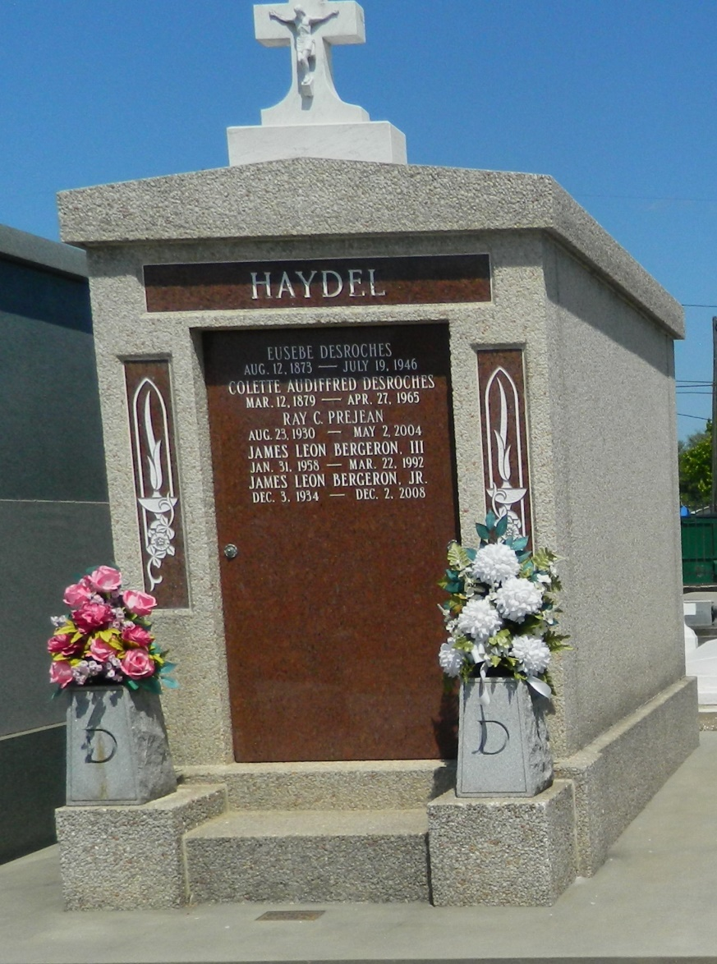

Ray Charles Prejean, a customer service representative for Winn-Dixie for 17 years, died Sunday of a heart attack at Kenner Regional Medical Center. He was 73. Mr. Prejean was born in Schriever and lived in Kenner for the past 33 years. He was a longtime volunteer at Kenner Regional Medical Center.

Survivors include his wife, Mary Lynn Haydel Prejean; two sons, David and Kevin Prejean; and two grandchildren.

A Mass will be said Wednesday at 11 a.m. at L.A. Muhleisen & Son Funeral Home, 2607 Williams Blvd., Kenner. Visitation will begin at 9 a.m. Burial will be in St. Peter's Catholic Cemetery in Reserve.

Times-Picayune, The (New Orleans, LA) - Tuesday, May 4, 2004

Contributed by Jane Edson