Edna Marie (Vicknair) Reine

December 16, 1914 – May 23, 2013

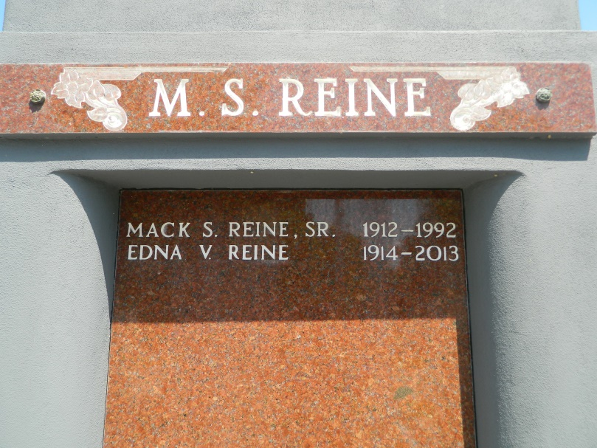

Edna Vicknair Reine, 98, passed away Thursday, May 23, 2013.  
  
She was the beloved wife of the late Mack S. Reine Sr., mother of Mary "Sis" R. Tamplain and Mack E. Reine Jr. and grandmother of Jeff Tamplain (Jacki), Jennifer T. Brady (Eugene), Barry (Belinda), Kent (Jane) and Mike Reine (Alisha). She is also survived by 11 great-grandchildren and four great-great-grandchildren.  
  
She was the daughter of the late Edward and Aurore Madere Vicknair and sister of Ruth Buckner, Miriam Hymel and the late Edward Vicknair Jr., Lezian Waguespack, Lucille Landry, Yolande Thibadoux, Berrenise Madere, Dorothy Marshand, Ruby Binning and Audrey Borne.  
  
She was a native of Reserve and a resident of LaPlace,  
  
Visitation and services were held at Millet-Guidry Funeral Home in LaPlace on Tuesday, May 28, 2013. Burial followed in St. Peter Cemetery in Reserve.

L'Observateur (La Place, LA) - Tuesday, May 28, 2013

Contributed by Jane Edson