Elma (Vicknair) Remondet

August 7, 1919 – May 22, 2006

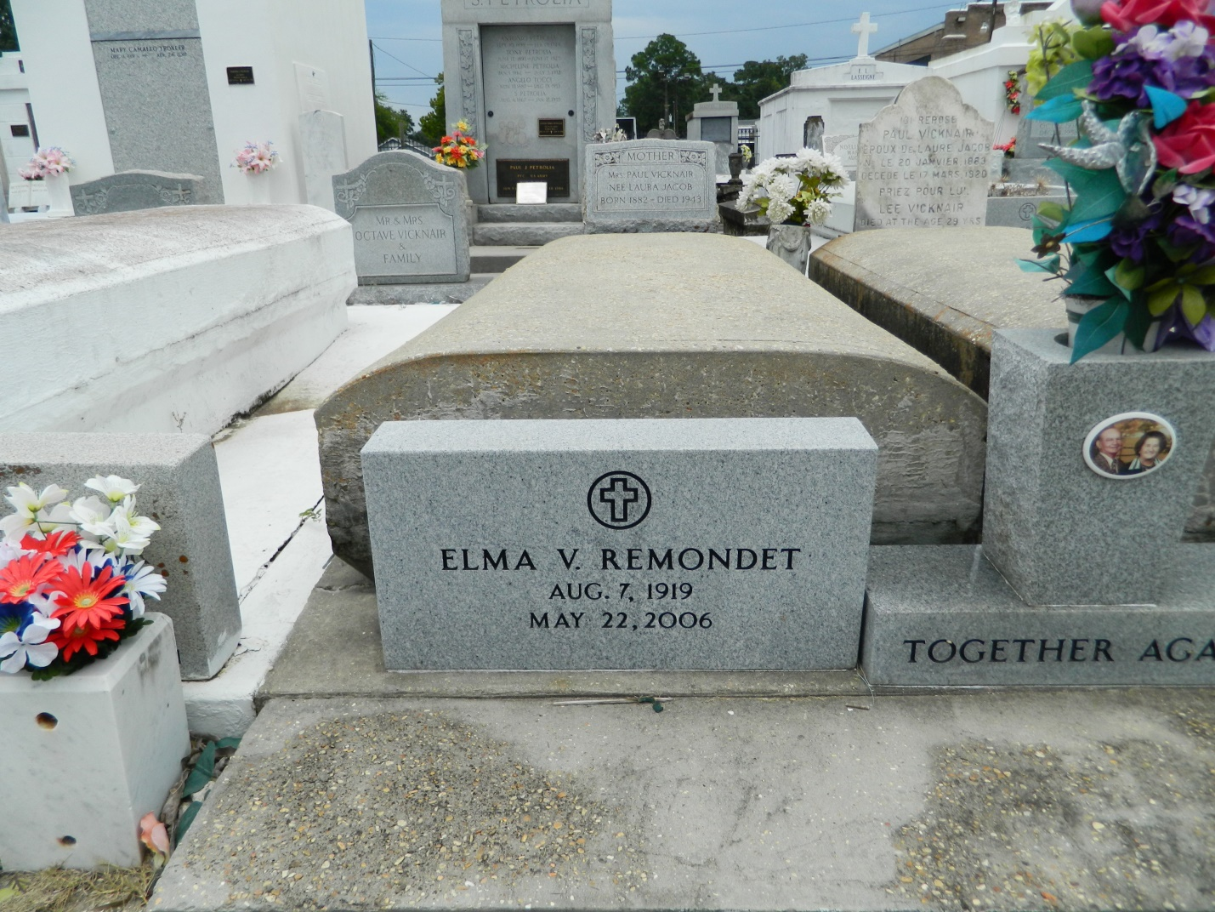

RESERVE - Elma Vicknair Remondet, 86, a native and resident of Reserve, died May 22. She was the wife of the late Claude Remondet Sr.   
 She is survived by children Michael (the late Polly) Remondet, Claude (Cathy) Remondet Jr., Gerald (Betty) Remondet, Paul (Karen) Remondet, Laura (L.J.) St. Martin, Cathy (Lenny) Wells and Birdie (the late David) Remondet and niece Shirley Clement Triche.  She is also survived by 16 grandchildren and 14 great-grandchildren.   
 She was preceded in death by her parents Paul and Laura Vicknair and siblings Lee and Lawrence Vicknair and Pearl Clement.   
 Services were held May 24 at St. Peter Catholic Church, Reserve, with interment in the church cemetery.

**L'Observateur (La Place, LA) - Tuesday, May 30, 2006**

**Contributed by Jane Edson**