Thelma M. (Booker) Robinet

June 8, 1914 – November 17, 2000

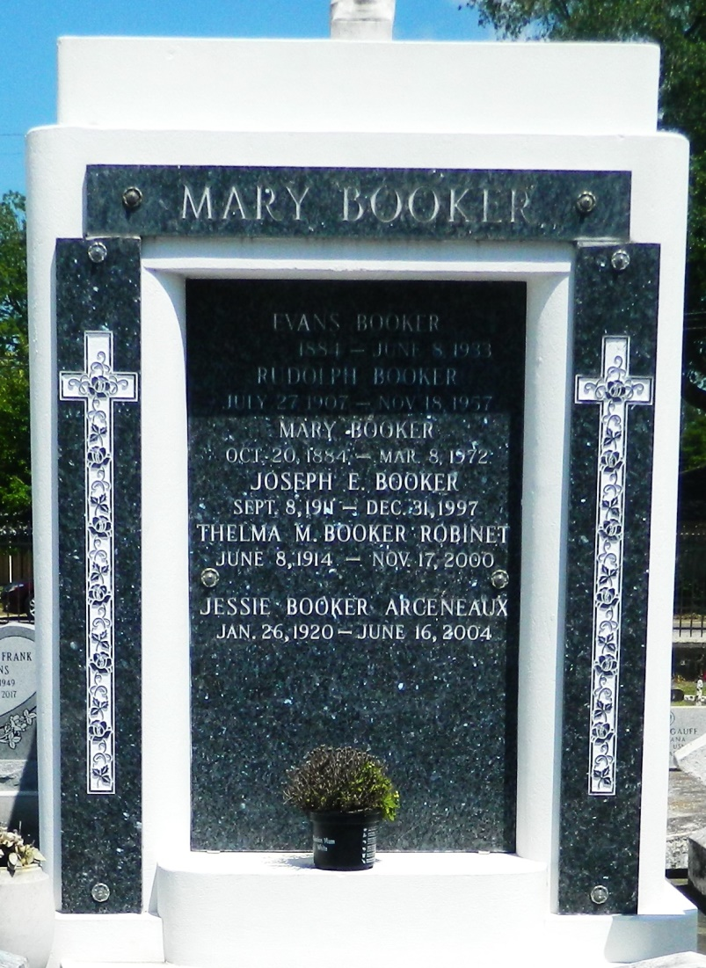

LAPLACE - Thelma Booker Robinet, 86, a native and resident of Reserve, died Nov. 17. She was the wife of the late Theophile Robinet and mother of McLouis and LaNard Robinet.  
 She was also the daughter of the late Evans and Mary Brown Booker and sister of Jessie Arceneaux, Isabella Keller and Royal Sr. and the late Rudolph and Joseph Booker.  
 She is also survived by 11 grandchildren and six great-grandchildren.  
 Services are today at 11 a.m. at St. Joan of Arc Catholic Church, LaPlace, with interment at St. Peter Cemetery, Reserve. Visitation starts at 9 a.m.

L'Observateur (La Place, LA) - Wednesday, November 22, 2000

Contributed by Jane Edson