Leo Schnyder

September 28, 1942 – April 17, 2000

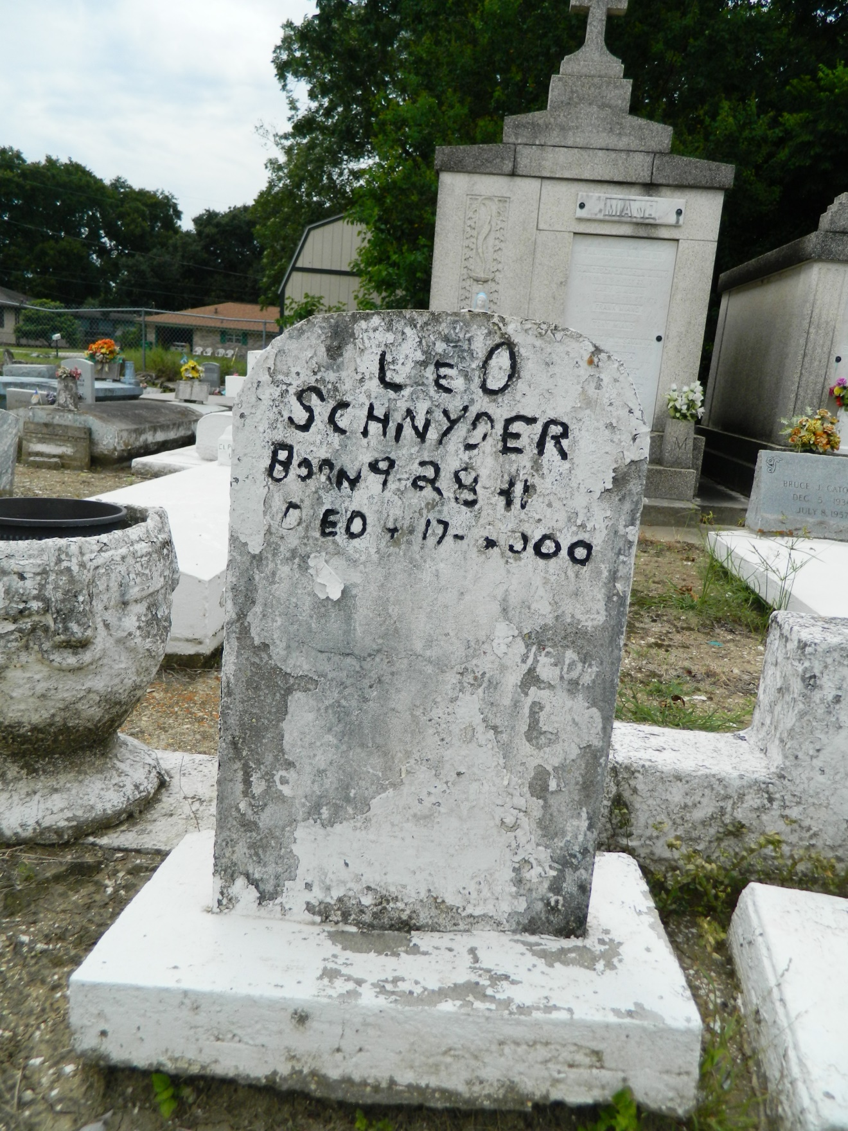

LOS ANGELES - Leo "Johnny" Schnyder, 58, a native of Reserve and resident of Los Angeles for the past 40 years, died April 17. He was the husband of Juliet Schnyder and father of Leo, Derek, Preston, Christopher, Kenyatta and Michael Schnyder. He was also the son of the late Pierre and Edna Schnyder and brother of Allen, Paul, Nicholas, Marjorie, Evangeline, Gregory and Ronald Schnyder. He was also survived by three grandchildren. Services were held April 24 at Our Lady of Grace Catholic Church, Reserve, with interment at St. Peter Cemetery, Reserve.

L'Observateur, LaPlace, LA; April 26, 2000