Paul Victor "Midget" Schnyder Sr.

June 25, 1939 – January 27, 2018

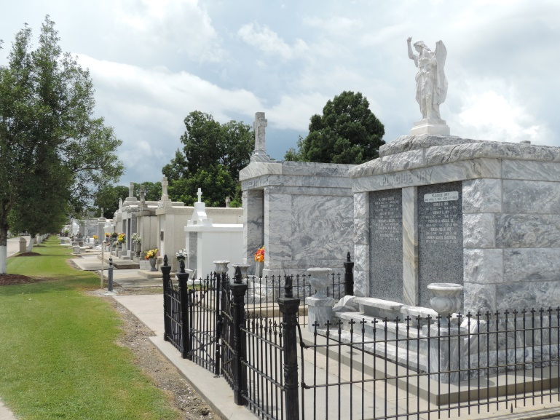

Paul “Midgit” Victor Schnyder Sr., son of the late Pierre Schnyder and Edna Roussell Schnyder was called to his Heavenly home on Saturday, January 27, 2018 at the age of 78 in Reserve, LA.   
He was a native of Reserve, LA. and spent a large part of his early years in Greensboro, North Carolina. He attended Our Lady of The Miraculous Medal Grammer School and Notre Dame High School in Greensboro, NC. He graduated from Our Lady of Grace High School in Reserve, LA.   
 He served 21 years in the U.S. Navy and retired as Master Chief Petty Officer (E8). After his military service, he was employed at Bayou Steel Corporation in Laplace, LA. He also retired from the St. John the Baptist Sherriff’s Office where he worked as a Deputy Sheriff promoted to Detective, Task Force and Inmate Work Program.

Loving father of Darlene Schnyder- Dean (Patrick), Paula Schnyder-Henderson (Wendell), Paul Victor Schnyder Jr. (Ingrid) and Victoria Warner (Larry). Brother of Nicholas Schnyder (Yvonne), Majorie Noble, and Evangeline Johnson (Norwood). Preceded in death by siblings Peter, Catherine, Allen, Leo, Gregory and Ronald Schnyder.

Relatives and friends are invited to attend the funeral service at New Wine Christian Fellowship, 1931 Airline Highway, Laplace, LA. on Friday, February 2, 2018 at 11:00a.m. Visitation from 9am. To 11am. Entombment at St. Peters Cemetery in Reserve, LA. Repast will follow at New Wine Multi-Purpose Room.

Special invitation to Bayou Steel, St. John the Baptist Parish Sheriff’s Office, U.S. Navy Veterans, and East St John High Athletics. He was a HUGE fan of Lady Heat Basketball and ESJ Girls and Boys basketball, baseball and football fan!   
Treasures of Life Funeral Services have been entrusted with his final care.  
“When someone you love becomes a memory, that memory becomes a TREASURE!

[www.treasurefunerals.com](http://www.treasurefunerals.com) online obit (accessed 10/7/2018)