Olga (Delauneuville) Sitzman

March 7, 1917 – June 24, 2005

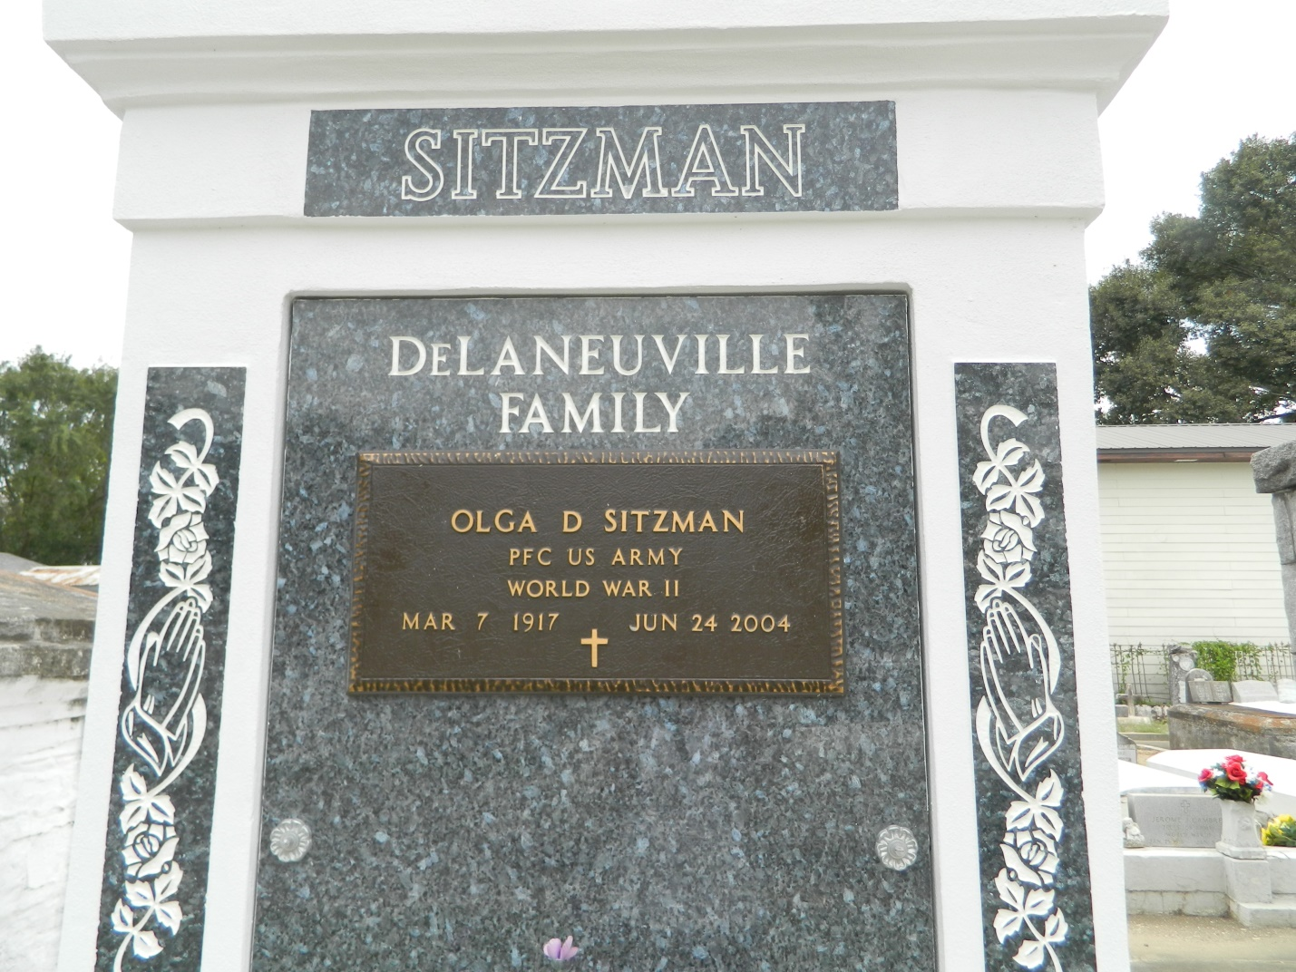

Olga D. Sitzman on Thursday, June 24, 2004 at 5:15 a.m. Beloved wife of the late Thomas Sitzman. Daughter of the late Emile Sr. and Corrine Vicknair DeLaneuville. Sister of the late Charles "Schoon", Nemour "Toon", Theophile "Sweet", Ellis, Emile Jr. and Theodore DeLaneuville, Virginia "Bebe" Duhe, Lucille "Frenchie" Schexnayder, Lydia Schwartz, Jeanette Jacob, Georgette Howard and Denise Michel. Also survived by numerous nieces and nephews. Age 87 years. A native of Reserve, LA and a resident of LaPlace, LA for the past 25 years.   
 Relatives and friends of the family, also members of the American Legion are invited to attend services. Visitation at Millet Guidry Funeral Home, 2806 W. Airline Hwy., LaPlace, LA on Wednesday, June 30, 2004 from 5 - 10 p.m. and on Thursday from 8 - 9:45 a.m. followed by religious services at Ascension of Our Lord Catholic Church, LaPlace, La at 10:00 a.m. Burial in St. Peter Church Cemetery, Reserve, LA. In lieu of flowers masses preferred.

**Times-Picayune, The (New Orleans, LA) — Wednesday, June 30, 2004**

**Contributed by Jane Edson**