Lynette Marie St. Martin

1921 – March 18, 2005

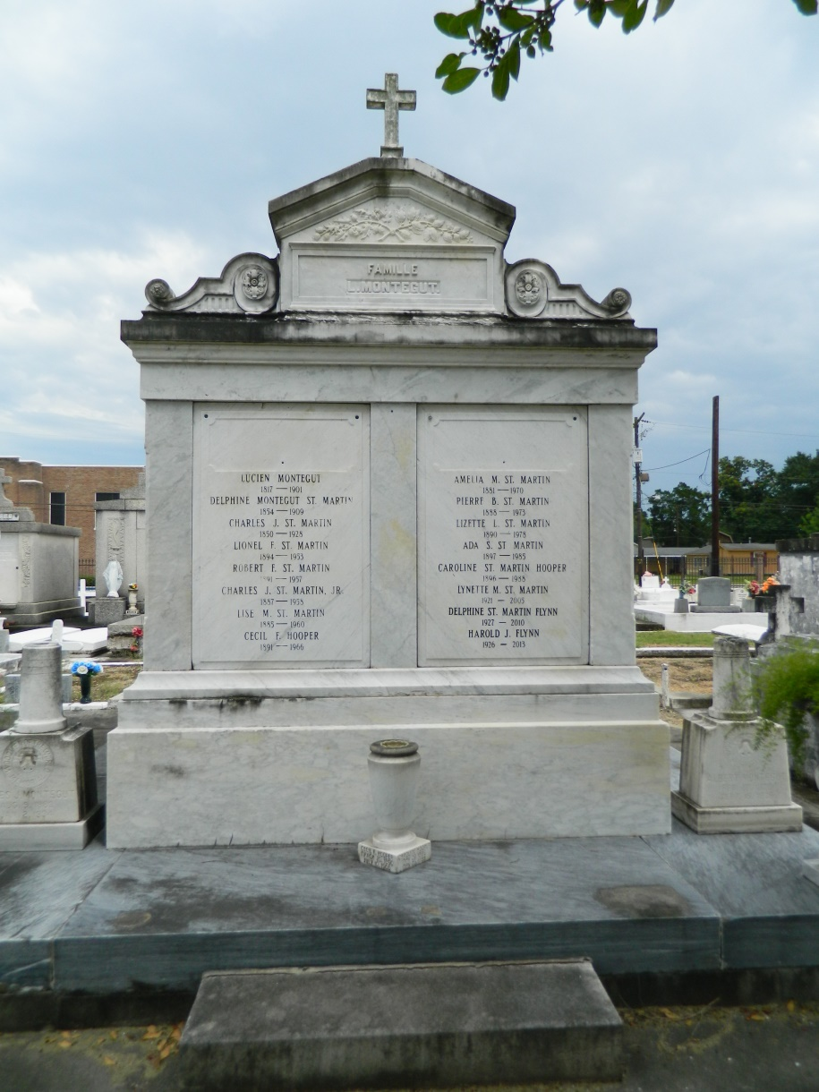 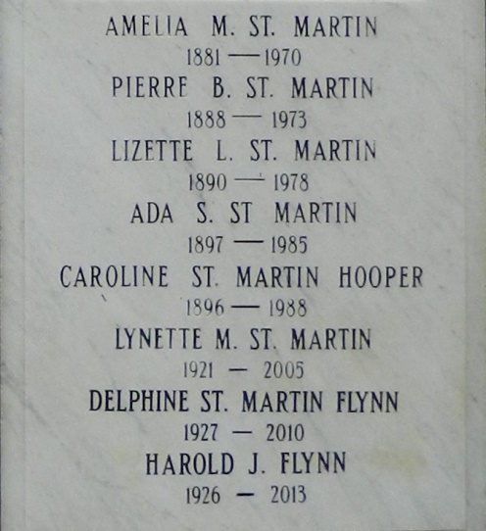

Lynette Marie St. Martin who died on Friday, March 18, 2005 at 12:15pm. She was the daughter of the late Lizette Labarre and Peter Bauchet St. Martin and sister of Leah Soulier, Marie Therese Richhart, Delphine Flynn, Gerard and Charles St. Martin and the late Peter, Jr. and Roland St. Martin. She is also survived by numerous nieces and nephews. A native of LaPlace and a resident of New Orleans.   
 Relatives and friend of the family are invited to attend services. Visitation at Milliet-Guidry Funeral Home, 2806 W. Airline Hwy., LaPlace, LA on Sunday, March 20, 2005 from 6pm to 8pm and on Monday, from 8am until 9:45am followed by a Mass of Christian Burial at St. Joan of Arc Catholic Church, LaPlace at 10am. Burial in St. Peter Cemetery, Reserve. The Rev. Msgr. Andrew Taormina, Pastor of St. Frances Xavier Catholic Church, Metairie, LA will serve as celebrant of the Mass. He will be assist. by Fr. Kenneth Allen

**Times-Picayune, The (New Orleans, LA) - Sunday, March 20, 2005**

**Contributed by Jane Edson**