Audrey (Millet) St. Pierre

October 26, 1934 – November 28, 2015

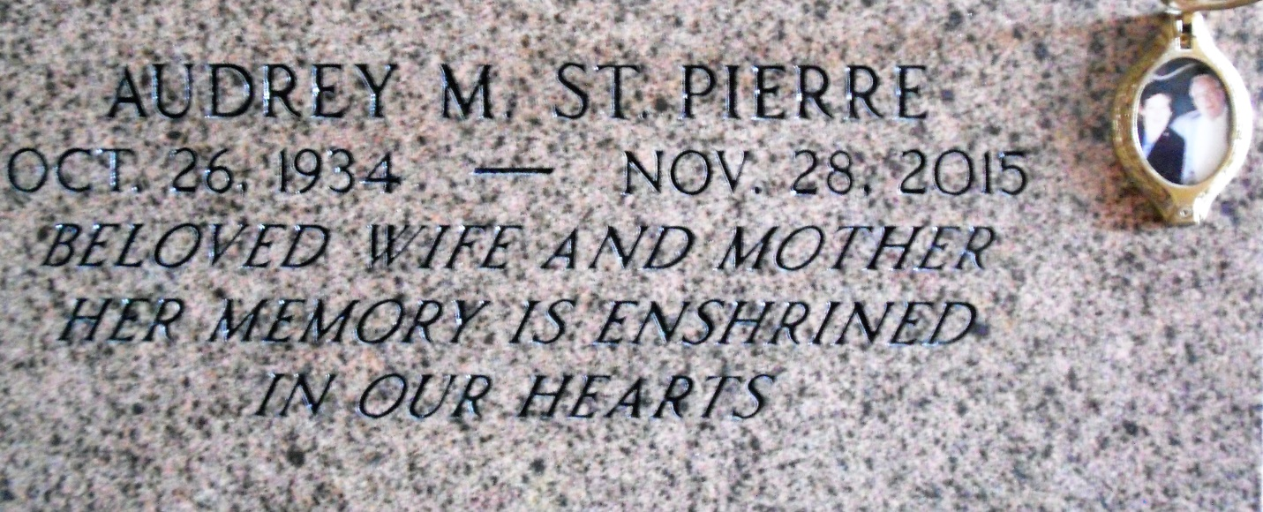

Photo by Team T Lo

Audrey Mae Millet St. Pierre, beloved wife, mother, mother-in-law, grandmother, great-grandmother, sister, aunt and friend, Audrey Mae Millet St. Pierre passed away while surrounded by her family on Saturday, November 28, 2015 at the age of 81. She was born on October 26, 1934 and was a native of Garyville, LA.   
 She was preceded in death by her son, Darren St. Pierre; her parents, Leonce and Emeline Millet; her sisters, Louise Pellissier Lemoine, Florence Porta, Helen Brady, Doris Louque Vicknair and Ferrell Ann Chauvin Stockton; and her brothers, Leonce Millet, Jr., Joseph “J.C.” Millet and Robert Millet, Sr.. She is survived by her husband, Allen J. St. Pierre, Sr.; their children, Darlene Vest, Kathleen Clement (husband, Randy), Suzanne Quinlan (husband, Joe) and Allen “A.J.” St. Pierre, Jr. (wife, Coy); grandchildren, Randy “Red” Clement, Jr., Jamie Clement, Dustin Clement, Crystal Vest, Lauren St. Pierre, Brandon St. Pierre, Lindie St. Pierre Robinson, Brooke St. Pierre, Lexi St. Pierre and Sophie St. Pierre and sixteen great-grandchildren. She is also survived by her sisters, Eunice Melancon and Lavonne Brady, and her brother, Arthur Millet.   
 She loved to dance, cook and she enjoyed preparing meals for family gatherings. She never forgot anyone’s birthday, and you could always find her enjoying her game shows and some of her favorite daily television soap operas and old movies. Her most enjoyable times were spent with her grandchildren and great-grandchildren. Regardless of how many challenges she faced in life, she was a strong woman of faith and spirit and an inspiration to her children. She will be dearly missed by her entire family.  
 Visitation will be held at St. Hubert Catholic Church, 176 Anthony Monica St. in Garyville on Wednesday, Dec. 2 from 9:00-11:00 AM, followed by a Mass of Christian Burial at 11:00 AM. Interment will follow at St. Peter’s Cemetery in Reserve, LA.

Unknown source contributed by LJCL16