Alvin Anthony Stein

April 9, 1936 – December 18, 2013

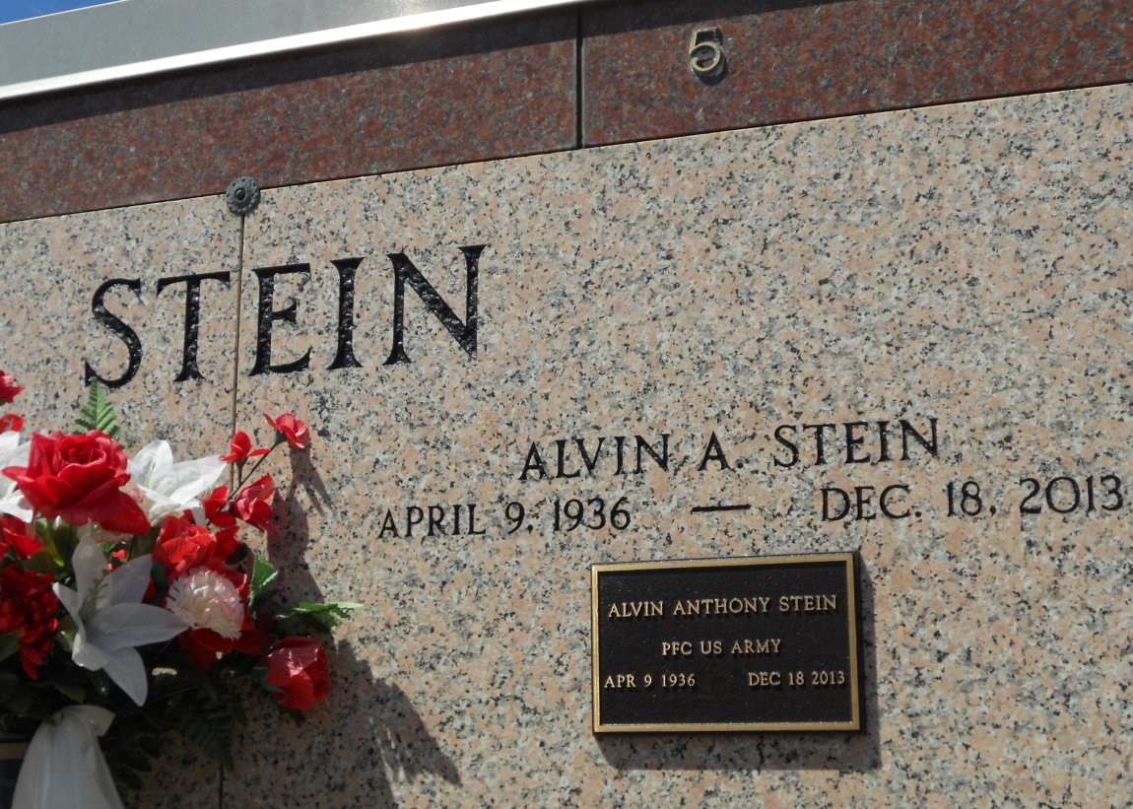

Photo by Team TLo

Alvin A. Stein died on Wednesday December 18, 2013, Beloved husband of Mary Fern Clement Stein for 54 yrs. Father of Kevin Stein (Linda), Angie Pelt, Lela Rushing (Tim), Monica Montz and Julie Roussel (Lowell). Grandfather of Austin and Evin Stein, Joshua, Aaron and Nicholas Rushing. Great-grandfather of Aubrey and Gavin Stein, Laynie and Joey Rushing. Son of the late Eluce and Archange Stein. Brother of Norris, Joseph, Paul, Nelson and Mary Ann Stein, Ruby McClean and the late Lena Vicknair, Josephine, Gladys, Theresa, and Jeanette Stein. Age 77. A native and resident of Reserve, LA. Relatives and friends are invited to attend services. Visitation at Millet-Guidry Funeral Home, 2806 W. Airline Hwy., LaPlace, LA on Friday December 20, 2013 from 5:00 pm to 9:00 pm and on Saturday from 9:00 am to 10:30 am, followed by Mass at St. Peter Catholic Church, Reserve at 11:00 am. Burial in St. Peter Cemetery.  
  
Published in TheAdvocate.com from Dec. 19 to Dec. 20, 2013