Alvin Joe Stewart

Abt. 1934 – November 12, 2019

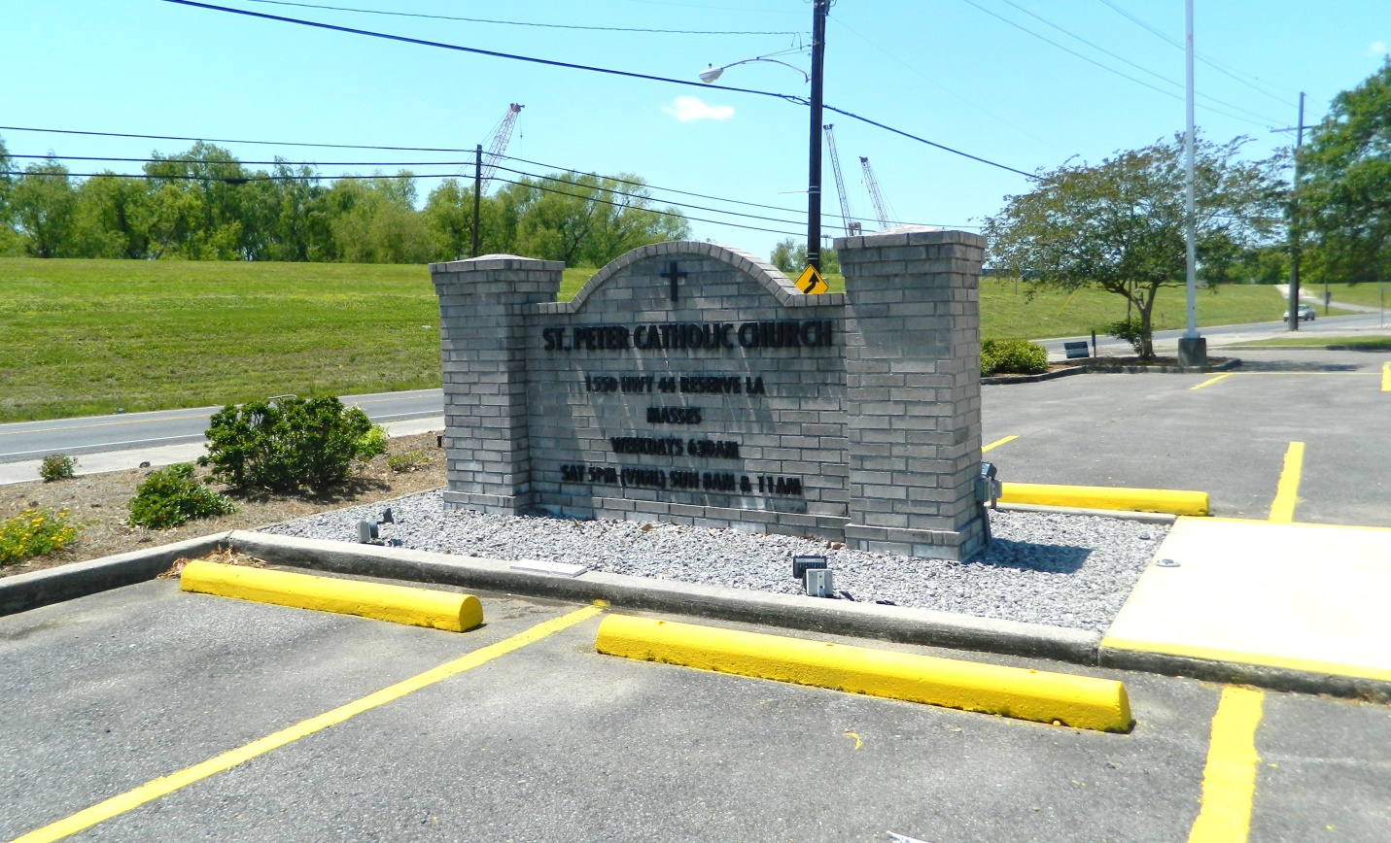

Alvin Stewart "Joe" "Joe La-Lay" on Tueday, November 12, 2019 at Ormond Nursing and Care Center, Destrehan, LA. Son of the late Emma Butler and Henry Stewart. Brother of the late Henry "Ton" Stewart, Albert "Prince" Stewart, Mildred "Teeta" Ferrygood, Walter "Shortee" Stewart, Stella S. "Mae Mae" Sanders, Harry "Soda" Stewart and Mary Louise "Titha" Stewart. Also survived by a host of nieces, nephews, cousins, other relatives and friends. Age 85 years. A native and a resident of Reserve, LA. Relatives and friends of the family, also priest and parishioners of Our Lady of Grace Catholic Church and all neighboring churches are invited to attend the Funeral Mass at Our Lady of Grace Catholic Church, 772 Hwy 44 (River Road), Reserve, LA on Monday, November 18, 2019 at 10:00 AM. Father Christopher Amadi, Celebrant. Interment St. Peter Cemetery, Reserve, LA. Visitation at the above named church from 8:15 AM until Mass time. Rosary 9:15 AM. The family would like to express "Special Thanks" to the Staff of Ormond Nursing and Care Center of Destrehan, LA and St. Catherine's Hospice for the compassion and care provided to Alvin Stewart. SERVICED BY ROBOTTOM

Published in The Times-Picayune, New Orleans, LA on Nov. 17, 2019