Louis C “Jessie” Tanguis Sr.

May 29, 1881 – October 11, 1951

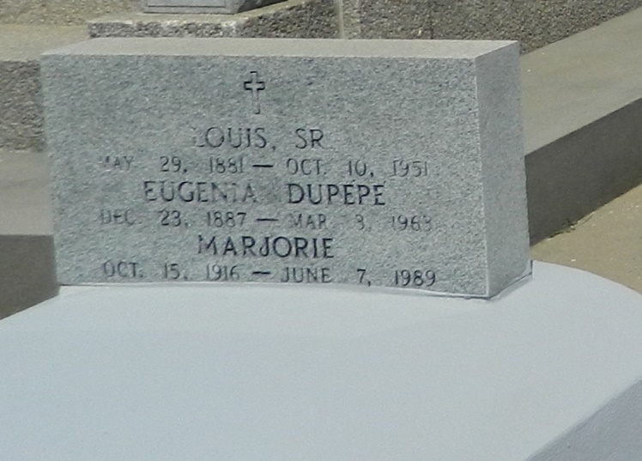

Died at Laplace, Louisiana, on Wednesday, 10 Oct 1951 at 10:30 in the morning. Husband of Eugenia Dupepe, age 70 years, a native of Laplace. Father of Mrs. Jules Vessier of Metairie, Louisiana, Marjorie Tanguis of Laplace, and Louis Tanguis Jr of Baton Rouge. Services were Thursday, 11 Oct 1951, at St Joan of Arc Church, Laplace, with interment in St Peter Cemetery in Reserve, Louisiana.

The Times-Picayune, New Orleans, LA; 11 Oct 1951  
  
NOTE: His Louisiana Death Certificate lists his birth as 15 May 1881. His World War I registration lists his birth as 5 Jun 1881. His grave marker has his birth as 29 May 1881.

Contributed by Dwayne Montz