Paul Francis Terrebonne Jr.

November 12, 1971 – November 2, 2005

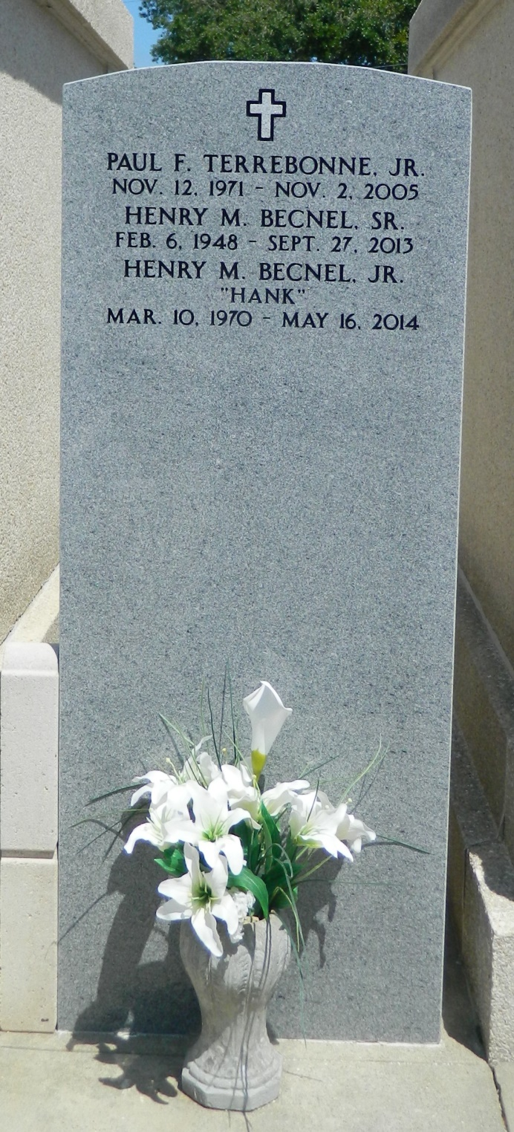

ST. CHARLES - Paul Francis Terrebonne Jr., 33, a native of New Orleans and a resident of Harahan and St. Charles Parish. He was the husband of Gina Becnel Terrebonne.  
 He is survived by his two children Peyton Paul and Heather Marie Dufrene Terrebonne.  
 He is also survived by his parents Yvonne Nickens Pichoff and Paul Francis Terrebonne Sr., stepparents Leann Terrebonne and Randy Pichoff, siblings Shawn (Michael) Anderson, Jason Becnel, Webster (Delina) Terrebonne and Garrett (Jessica) Terrebonne, stepsister Shannon Pichoff Truxillo, stepbrother Shawn Joseph Pichoff, nephews Alan Kirkfield III, Tye Anderson, Julian Terrebonne, Dillon Truxillo, Sage Pichoff, Tyler Cambre and Austin Becnel and nieces Abigael Anderson, Maddigan Terrebonne and Darian Truxillo.  
 He was preceded in death by his grandparents Earl and Bessie Richardson Nickens and Webster and Beverly Pellerin Terrebonne.  
 Services were held Nov. 8 at L.A. Muhleisen and Son Funeral Home Chapel, Kenner.

L'Observateur (La Place, LA) - Monday, November 14, 2005

Contributed by Jane Edson