Hortense M. Torres

January 11, 1903 – December 27, 2000

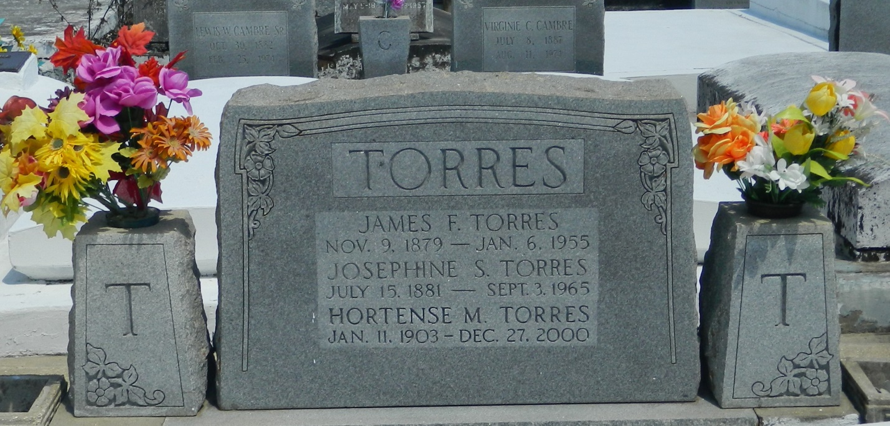

LAPLACE - Hortense "Nenaine" Torres, 97, a native of Vacherie, former resident of Reserve and resident of Mandeville, died Dec. 27. She was the daughter of the late James and Josephine Torres and sister of the late Fernand, Edmond, Ernest, Eddie and Netter Torres. Services were Dec. 29 at St. Peter Catholic Church, Reserve, with interment at the church cemetery.

L'Observateur (La Place, LA) - Saturday, December 30, 2000

Contributed by Jane Edson