Adam Leonce Tregre

August 30, 1872 – March 10, 1961

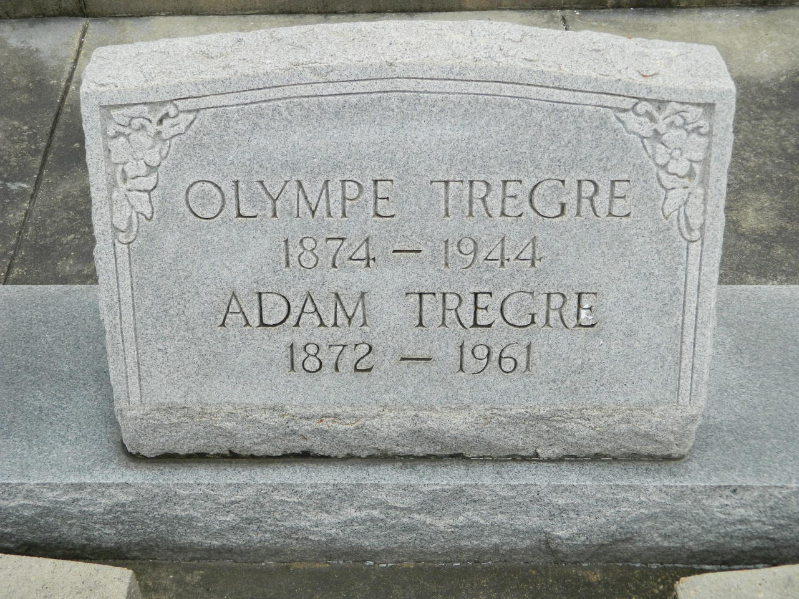

TREGRE – In New Orleans, La., on Friday, March 10, 1961 at 2:10 o’clock p.m. Adam Leonce (Boy) Tregre, husband of the late Olympia William, father of Mrs. George Brown of New Orleans, La., Mrs. John Haydel of Lutcher, La., Mrs. Conrad Spatz of Metairie, La., Peter Tregre of Garyville, La. and the late Elmore Tregre, also survived by 16 grandchildren and 29 great-grandchildren. Age 89 years. A native of Garyville, La. and a resident of Metairie, La.

Relatives and friends of the family are invited to attend the funeral. Services from Millet Funeral Home, Reserve, La. on Sunday, March 12, 1961 at 2:30 o’clock p.m. Religious services at St. Peter church, Reserve, La. Interment in St. Peter cemetery, Reserve, La. Parlors will be open Saturday at 3 o’clock p.m.

Unnamed newspaper clipping contributed by Dale Tregre