Jason Emanuel Vicknair

April 23, 1976 – August 7, 2009

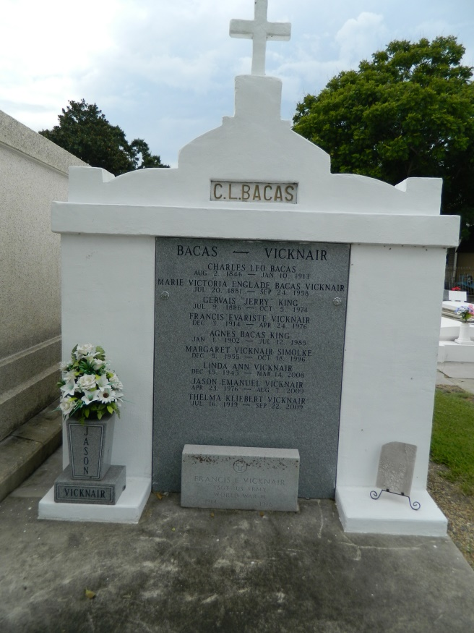 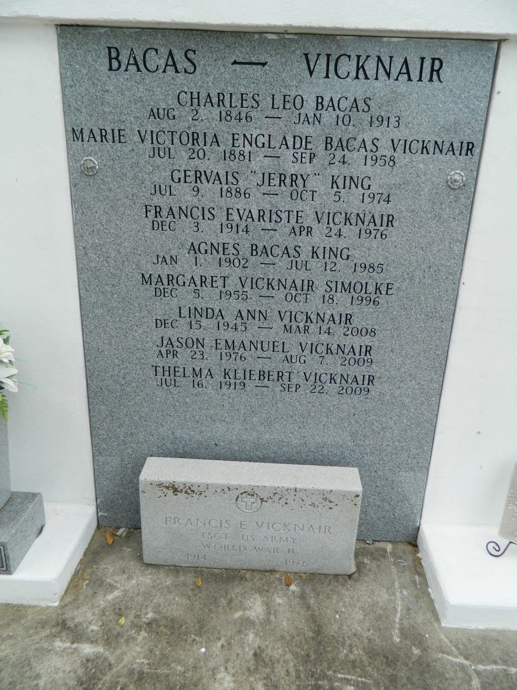

Jason Emanuel Vicknair on Friday, August 7, 2009 at 12:00 pm. Beloved son of Tommy and Brenda Bourgeois Vicknair. Father of Anicet Evarist Vicknair. Brother of Lynn Vicknair Jr., Summer V. Broussard, Winter V. Sameluk, Jean-Pierre, April and Austin Vicknair. Grandson of Thelma and the late Frances Vicknair and Owen Sr. and the late Della Jean Bourgeois. Jason was

so loved and will be deeply missed. Age 33. A native of Reserve and a resident of Metairie.   
 Relatives and friends are invited to attend services. Visitation at Millet-Guidry Funeral Home, 2806 W. Airline Hwy, LaPlace, La., on Tuesday, August 11, 2009 from 10:30 am to 12:30 pm. Followed by Religious Services at the funeral home chapel at 12:30 pm. Burial in St. Peter Cemetery, Reserve, La.

**Times-Picayune, The (New Orleans, LA) - Monday, August 10, 2009**

**Contributed by Jane Edson**