Linda Ann Vicknair

December 15, 1945 – March 14, 2008

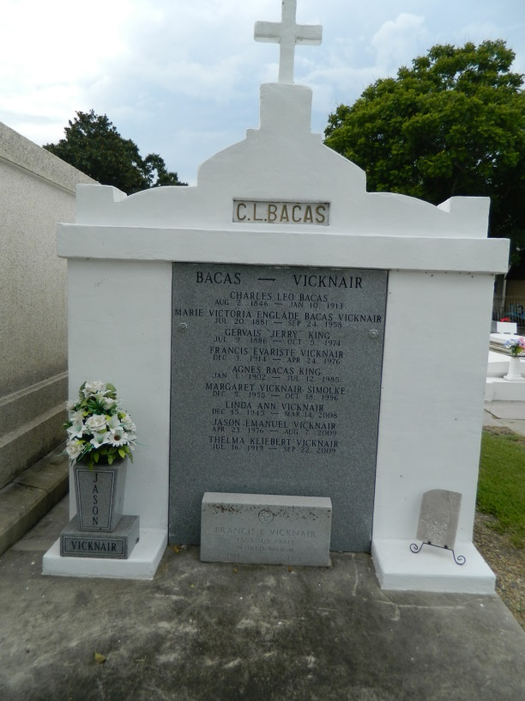 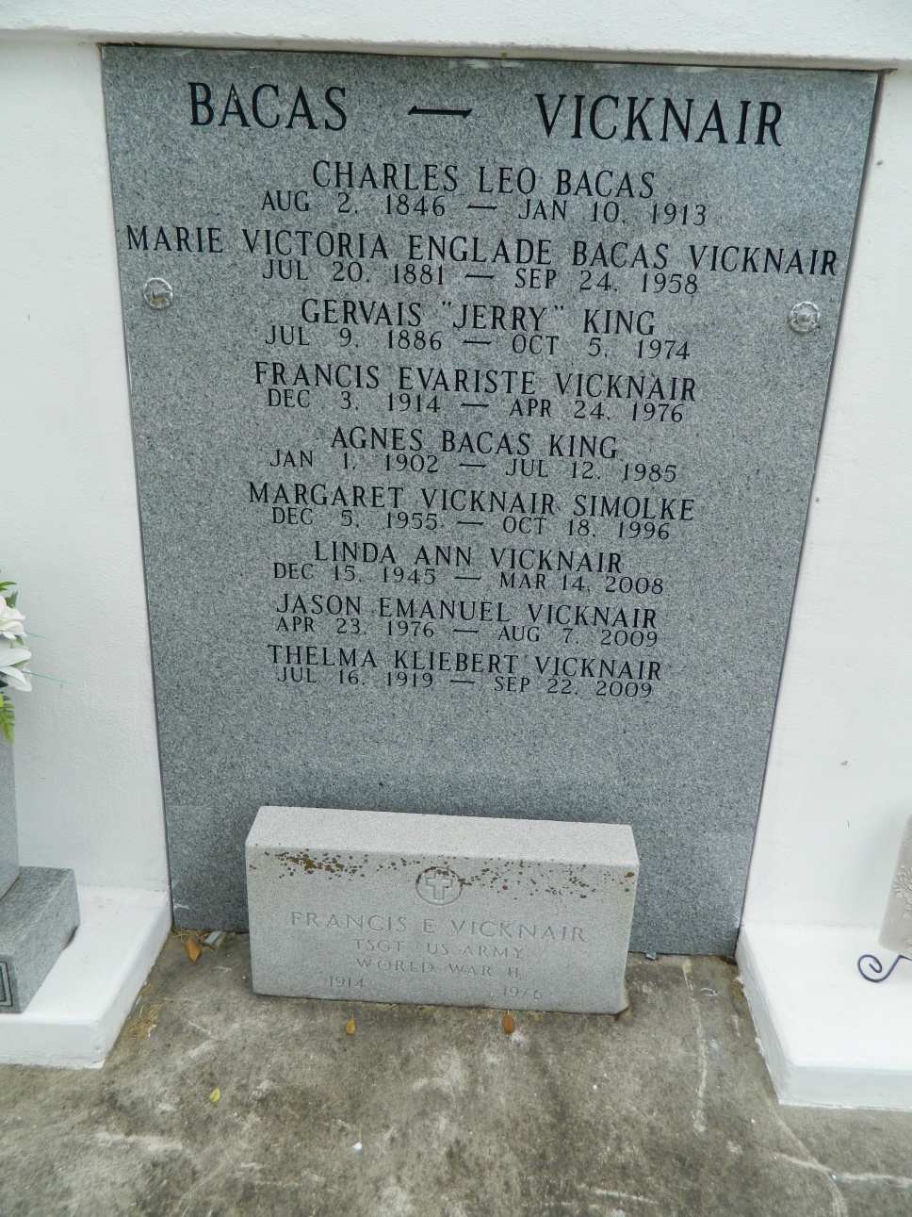

Linda Ann Vicknair went to be with the Eternal Lord on Friday, March 14, 2008. She was 62 years of age and a native of New Orleans and a resident of Metairie for the last 10 years. She was the daughter of Thelma Elizabeth Kliebert Vicknair and the late Francis Vicknair. Sister of Patrick Vicknair, Cynthia Vicknair, Tommy Vicknair, Ronald Vicknair and the late Sharon Luce, Margaret Vicknair and Daniel Vicknair. She is also survived by a host of nieces and nephews, and in-laws: Brenda, Fran, Paul and Gene.   
 Funeral Services will be held at Schoen Funeral Home, 3827 Canal St., New Orleans, on Tuesday, March 18, 2008. Visitation will begin at 10:00 AM and last until 12 Noon when a Funeral Mass will be held in the Chapel. Interment will follow in St. Peter's Cemetery in Reserve, LA.   
 Family and friends may view and sign an online guestbook at [www.legacy.com](http://www.legacy.com/).

**Times-Picayune, The (New Orleans, LA) - Monday, March 17, 2008**

**Contributed by Jane Edson**