Thelma (Kliebert) Vicknair

July 16, 1919 – September 22, 2009

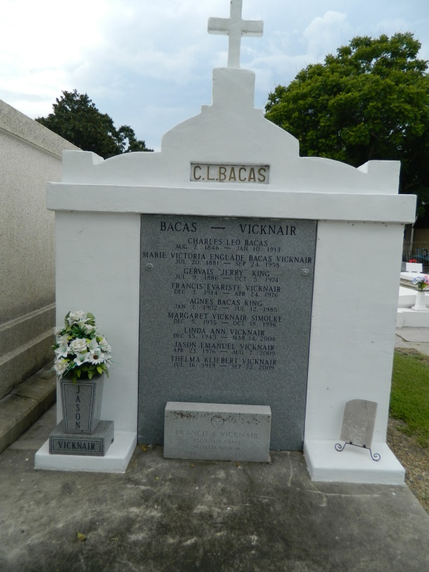 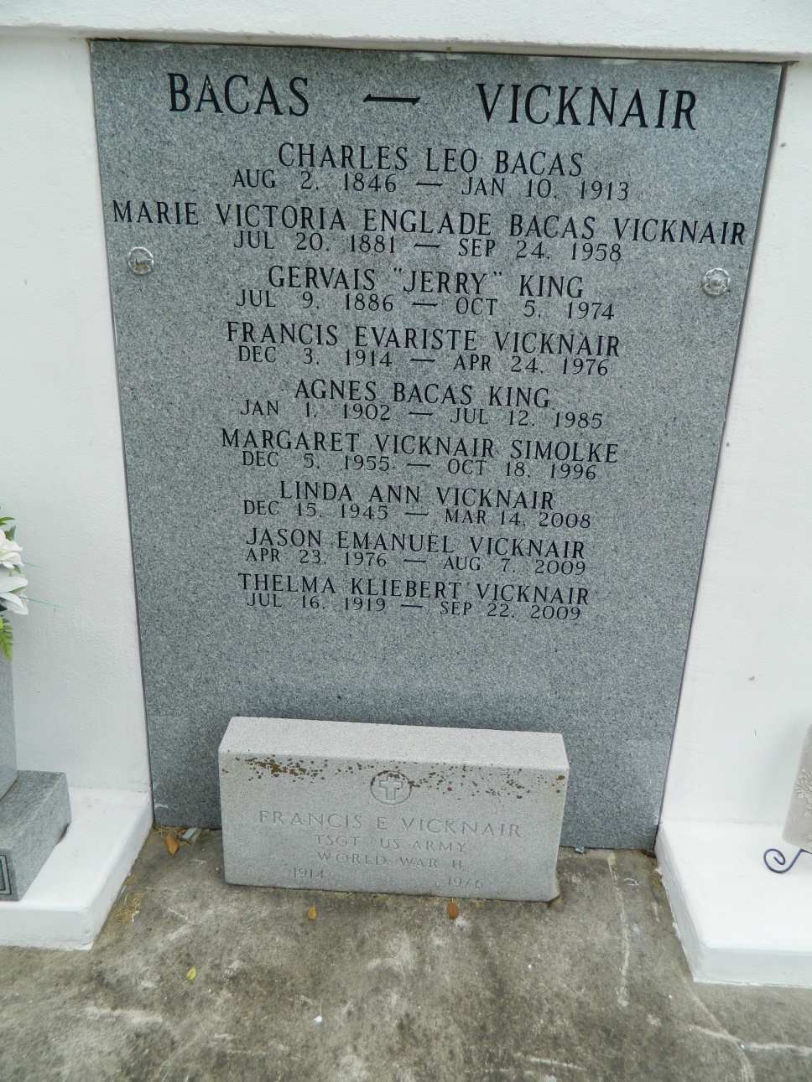

Thelma Kliebert Vicknair passed away on Tuesday, September 22, 2009. She was a native of Garyville, LA and a resident of Metairie, LA for the past 13 years. She was 90 years old. She was the beloved wife of the late Francis E. Vicknair and the loving mother of the late Linda A. Vicknair, Patrick S. Vicknair, Sr., the late Daniel M. Vicknair, the late Sharon V. Luce, Cynthia M. Vicknair, Lynn T. Vicknair, Sr., the late Margaret V. Simolke, and Ronald J. Vicknair. She was the mother-in-law of Frances, Brenda, Paul and Gene. She was preceded in death by her parents, Anicet J. and Ella B. Kliebert, and 2 grandsons: Damien R. Luce and Jason E. Vicknair. She is survived by 10 grandchildren: Jody, Patrick, Jr., Lynn, Jr., Daniel, Christian, Summer, Winter, Jean-Pierre, April, and Austin, 10 great-grand-children: Amanda, Kenny Paul, Dylan, Damien, Lynn Thomas III, Danny Jr., Brilee, Brady, Brennan, and Anicet, 2 sisters and 1 brother, as well as a host of nieces and nephews.   
 A Funeral Mass will be held at St. Peter's Church, 1550 Hwy. 44, Reserve, LA, on Friday, September 25, 2009 at 1:00 PM. Visitation will be at Jacob Schoen and Son Funeral Home, 3827 Canal St., New Orleans, from 9:30 AM until 12:00 noon. Interment will be in St. Peter's Cemetery in Reserve, LA.   
 An online guest registry is available at [www.schoencanalstreet.com](http://www.schoencanalstreet.com/).

**Times-Picayune, The (New Orleans, LA) - Thursday, September 24, 2009**

**Contributed by Jane Edson**