Gustina (Baham) Webre

Abt. 1936 – February 10, 2020

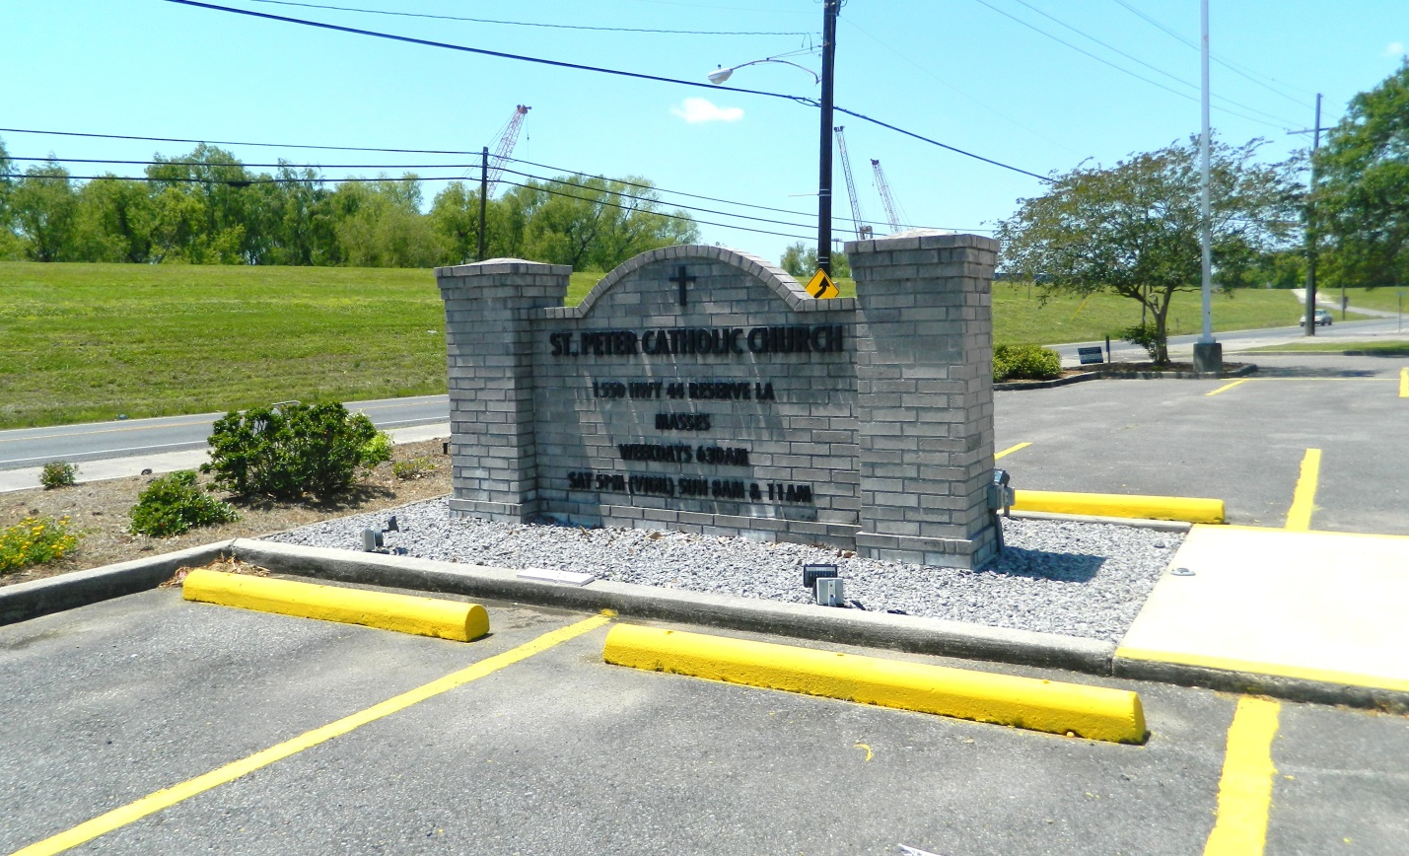

Gustina “Gussie” Baham Webre, a native of Folsom, LA and resident of Reserve went to be with her Lord and Savior, Jesus Christ on Monday, February 10, 2020 at the age of 84 after fighting a courageous battle with cancer.  She was retired from the St. John the Baptist Parish library.  Beloved wife of the late, Theodore H. Webre, Sr.

She leaves her children and spouses to cherish her memory; Lori and Todd Warner, Dawn M. Webre, Theodore “Theo” and Jennifer Webre, Jr. and Carol A Webre;  grandchildren, Tori Warner, Kami Warner, John Webre, Caroline Webre, Theodore “Tre” Webre, III, Emma Webre and Joseph “Lee” Meyers, III;  brothers and sisters, Jackson, Clyde, Lloyd, Bryant and Veronica Baham and Margaret Bowden;  along with many nieces, nephews, relatives and friends.

She was preceded in death by her parents, Clarence and Fener Populis Baham; and sisters, Angelina Landry, Nathalie Lathem and Virginia Ann Baham.

Visitation will be on Thursday, February 13, 2020 at St. Peter Catholic Church in Reserve, LA from 9:00 AM until funeral time.  A Mass of Christian Burial will be celebrated at 11:00 AM.  Interment will follow in the church cemetery. Rose Lynn Funeral Services are entrusted with handling her arrangements.

Rose Lynn Funeral Home, Lutcher, LA; February 11, 2020