Blandine (Hymel) Williams

December 9, 1915 – December 4, 2005

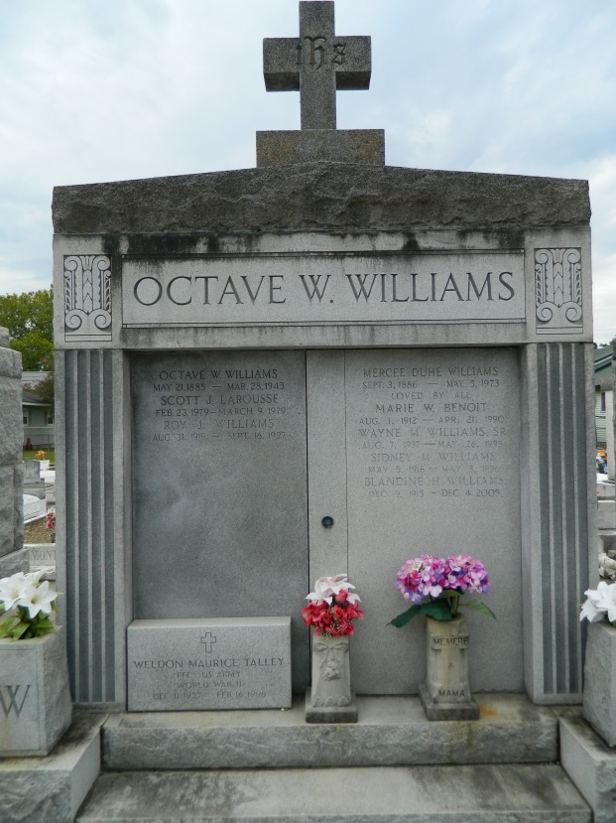 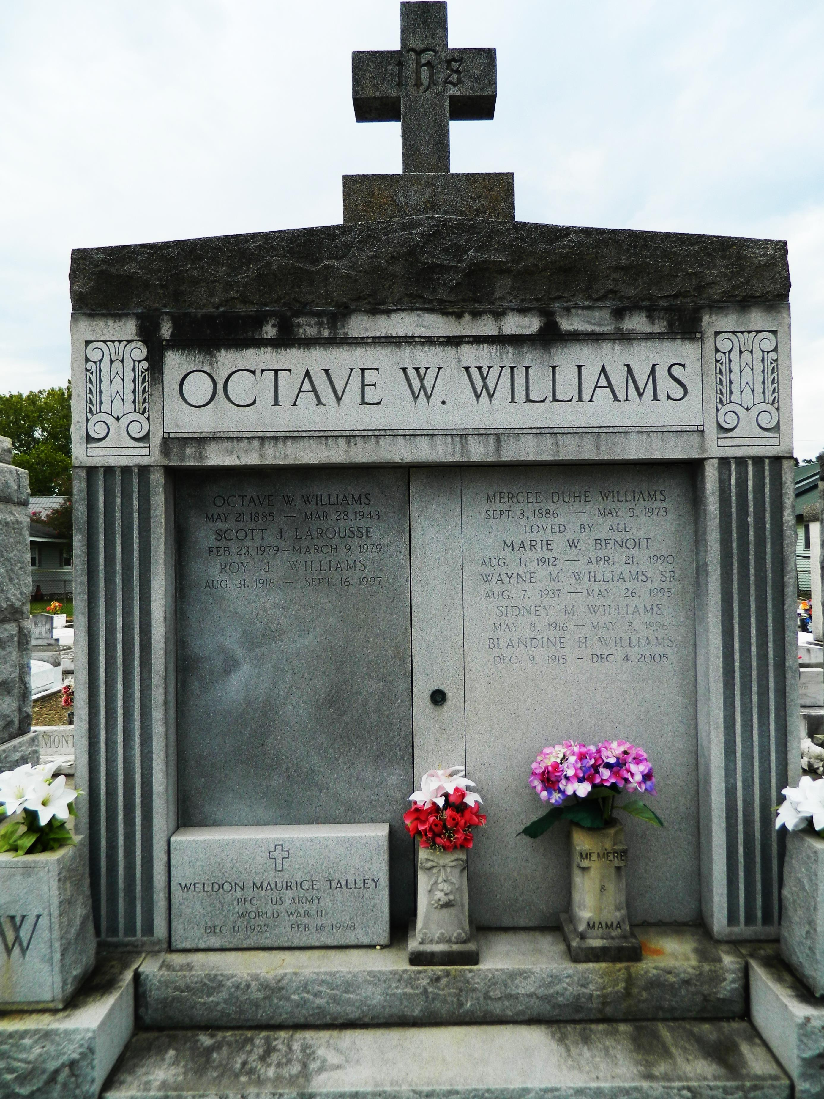

RESERVE - Blandine Hymel Williams, 89, a native of Edgard and a resident of Reserve, died Dec. 4. She was the wife of the late Sidney M. Williams.

She is survived by her children Katherine W. Larousse, Donald and Joan Williams.  She is also survived by her siblings Rose Trosclair, Arnold, Albin and Clement Hymel, grandchildren Belinda L. Drewitt, Melissa F. Rayburn, Celeste Larousse, Crystal L. Aiola, Richard Frazier Jr., Wayne Jr., Tyrone, Darren, Donald Jr. and Brandon Williams, 20 great-grandchildren and daughters and son-in-law Jean Ann and Brenda B. Williams and Sergent Larousse.   
 Services will be held today at 11 a.m. at St. Peter Catholic Church, Reserve, with interment in St. Peter Cemetery, Reserve.  Millet-Guidry Funeral Home is in charge of arrangements. Visitation begins at 9 a.m. at the church.

**L'Observateur (La Place, LA) - Wednesday, December 7, 2005**

**Contributed by Jane Edson**