Joseph P. Williams

May 14, 1925 – July 22, 2004

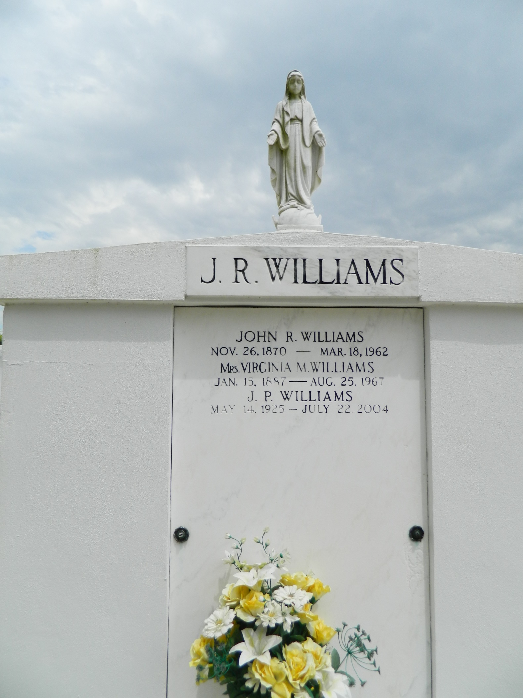

Joseph (J. P.) Williams on Thursday, July 22, 2004 at 11:41 am. Beloved son of the late John R. and Virginia Montz Williams. Brother of Peter Williams, Rita Simon, Ethel Mae Trosclair, Joyce Graugnard, Myrtis Guidry and the late Willis, Nicholas, Gilbert, Richard, Roland and O. J. Williams, Johnelle Hargis and Lucette Duhe. Special thanks to Kenner Regional Hospital, Luling Living Center and River Region Hospice. Age 79. A native of Lions, LA. and a resident of LaPlace for the past 30 years.   
 Relatives and friends of the family are invited to attend services. Visitation at St. Peter Catholic Church, Reserve on Monday, July 26, 2004 from 9:00 AM to 11:00 AM. Followed by religious services in the church at 11:00 AM. Burial in church cemetery. Arrangements by MILLET-GUIDRY FUNERAL HOME, LaPlace.

**Times-Picayune, The (New Orleans, LA) — Saturday, July 24, 2004**

**Contributed by Jane Edson**