Barbara (Bourgeois) Wright

February 21, 1941 – June 6, 2012

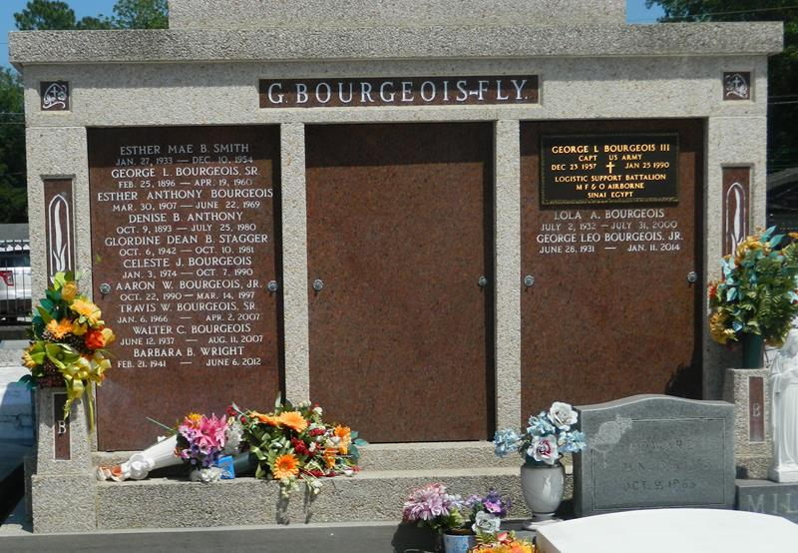

Barbara B. Wright on Wednesday, June 6, 2012 at her home in LaPlace, LA. Daughter of the late Esther Anthony and George Bourgeois, Sr. Wife of the late Typsy James Wright, Sr. Mother of Linda Marie Wright, Margie W. Johnson (Richard) and the late Typsy J. Wright, Jr. Guardian mother of Judy S. Snyder. Sister of George Bourgeois, Jr., Wallace Bourgeois, the late Gloria Dean B. Staggers, Esther Mae B. Smith and Walter Bourgeois. Also survived by 3 grandchildren, 3 great grandchildren and a host of nieces, nephews, other relatives and friends. Age 71 years. A native and resident of LaPlace, LA.  
 Relatives and friends of the family, also priest and parishioners of Our Lady of Grace Catholic Church and all neighboring churches and employees of Avis Budget Car Rental, St John the Baptist Parish School Board, Allied Barton Security and DuPont are invited to attend the Funeral Mass at Our Lady of Grace Catholic Church, 772 Highway 44 (River Road), Reserve, LA on Friday, June 15, 2012 at 11:00 AM. Fr. Christopher Amandi, SSJ Celebrant. Interment St. Peter Cemetery, Reserve, LA. Visitation at the above named church from 9:00 AM until Mass time.  
 SERVICED BY ROBOTTOM

Times-Picayune, The (New Orleans, LA) - Thursday, June 14, 2012

Contributed by Jane Edson