Deborrah Marie Dumas

Abt. 1960 – July 12, 2016

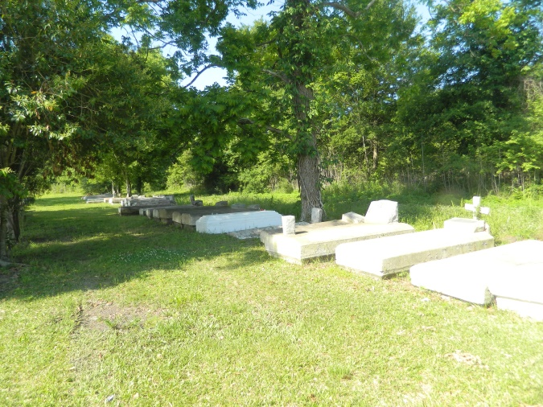

Surrounded by family at West Jefferson Hospital, on Tuesday, July 12, 2016, Deborrah Marie (Zeke) Dumas was called to her heavenly home to be with the Lord at the age of 56.

She was the mother of Dylan Dumas, grandmother of Aiden Dumas, daughter of the late Curtis and Julia Dumas. Sister of Larry Dumas of New Orleans, Clifford Dumas (Ellen) of Slidell, Ronald Dumas (late Stephanie) of Wallace, Ernest Dumas (Darcell) of Detroit, MI., Leo Dumas (Mary), Patricia Dumas, of Hahnville, LA, Alana Dumas of Los Angeles, CA. and the late Curtis (Linda), Jerry (Diane), Harold (the late Tyra) Dumas, Clarence Sr., Olga Mae and Lily Miles, devoted aunt Shirley Ross. Also survived by a host of other relatives and friends.

Relatives and friends of the family, also employees of Popeye's Chicken, Rooms to Go, Sonic and West St. John Class of 1978 are invited to attend funeral service on Friday, July 22, 2016 for 10:00am at Morning Star Baptist Church in Wallace, LA.-Rev. Frank Johnson officiating. Visitation begins at 8:00am. A gathering of friends and family will take place on Thursday, July 21, 2016 from 4pm to 6pm at Treasures of Life-Center for Life Funeral Services at 315 E. Airline Hwy, Gramercy, LA who have been entrusted with her final care. Interment at Willow Grove Cemetery, Wallace, LA.

TheNewOrleansAdvocate.com

July 19 to July 22, 2016