Harold Dumas

September 19, 1943 – February 9, 1975

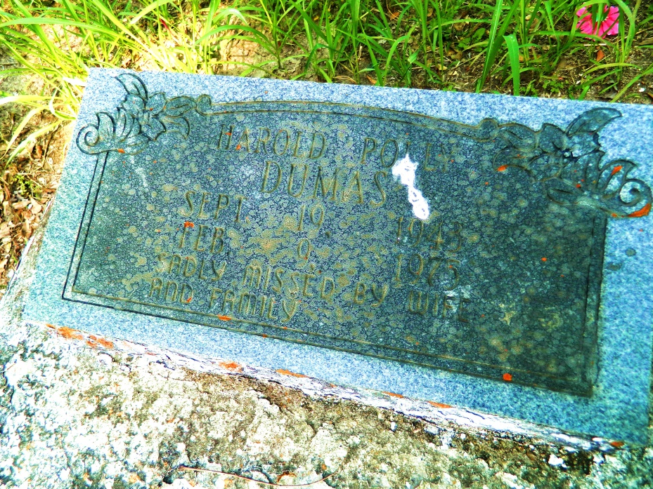

Harold (Polly) Dumas, of Wallace, La.; at Union; La.; on Saturday February, 9, 1975 at 3:00 o’clock a.m.; beloved husband of Mrs. Thyra Weber Dumas; son of Mr. Curtis Dumas, Sr. and Mrs. Julia Jones Dumas, born of Wallace, La.; brother of Curtis, Jr., Larry, Clifford, Ronald, Ernest, Leo, Clarence, Lillian, Thyles, Olga Mae, Patricia, Debra and Alana Dumas, all of Wallace, La. and the late Jerry Dumas, nephew of Alvin jones, Theresa Jackson, Lawrence Harris and Cornelius Dumas Sr.; great-nephew of Willis and Cora Jones; also survived by a host of other relatives and friends, age 31 years; a native and resident of Wallace, La.  
  
Relatives and friends of the family, also pastors, officers and members of the New Jerusalem Baptist Church, Edgard, La. and all neighboring churches, employes of Quinco, Inc, Triad Chemical, Donaldsonville, La.; Local No. 102, A.F.U., Baton Rouge Vocational Training School; St. John Parish Schools, St. John Parish Schools, West St. John Jaycees Marauders Boys and Girls Soft Ball Teams, Willow Grove Benevolent Society; Labor Aid Society; Wantu Wazuri Pleasure Club, are invited to attend the funderal service, from the New Jerusalem Baptist Church, Edgard, La., on Wednesday, February 12, 1975, at 12:00 o’clock noon. Reverend C.A. Washington, officiating.  
  
Interment in Willow Grove Cemetery, Wallace, La. Wake services on Tuesday night, February 11, 1975 at the above named church at 8:30 o’clock p.m.  
  
Earl Baloney and Sons Mortuary in charge.

Unknown source