Larry James “Mickey” Dumas   
April 6, 1936 - November 3, 2019

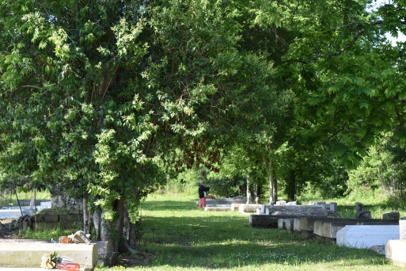

He was born to the late Curtis & Julia Dumas, the second of thirteen children. He leaves to cherish his wife (Jamesetta Herbert), 2-sons Micheal (Jennifer), John and one grandson (Leo), four brothers Clifford (Ellen), Ronald (Stelphiner), Ernest (Darcel), Leo (Mary), and sisters Patricia and Alana. One aunt Shirley Ross and two former sister-in-law Lucretia Dumas & Joy Evans and a host of nieces, nephews, relatives and friends.   
 Larry was educated at Wallace Rosenwald Elementary School and graduated Second Ward High School (1954). He was a member of the United States Coast Guard from 1954 to 1962, as a BM3 3rd Class Petty Officer. Larry was employed at the Veterans Administration Hospital in New Orleans, Louisiana.  
 He is proceeded in death by his parents (Curtis & Julia). Four brothers Curtis Jr, (Linda), Jerry (Diane), Harold (Thora), Clarence and three sisters Lillian Myles (Walter), Olga Mae and Debra.  
 All neighboring communities and churches are invited to join the family at Morning Star Missionary Baptist Church, 5355 Highway 18, Wallace, Louisiana 70090 on Wednesday, December 4, 2019 at 10:00 am. Visitation at 9 am until service time. Interment at Willow Grove Cemetery, Wallace, LA. Final care entrusted to Treasures of Life Funeral Services, 315 E. Airline Highway, Gramercy, LA 70052.

Treasure of Life Funeral Services, Gramercy, LA (accessed 1/29/2020)