Stelphiner (Grows) Dumas

September 3, 1944 – July 17, 2004

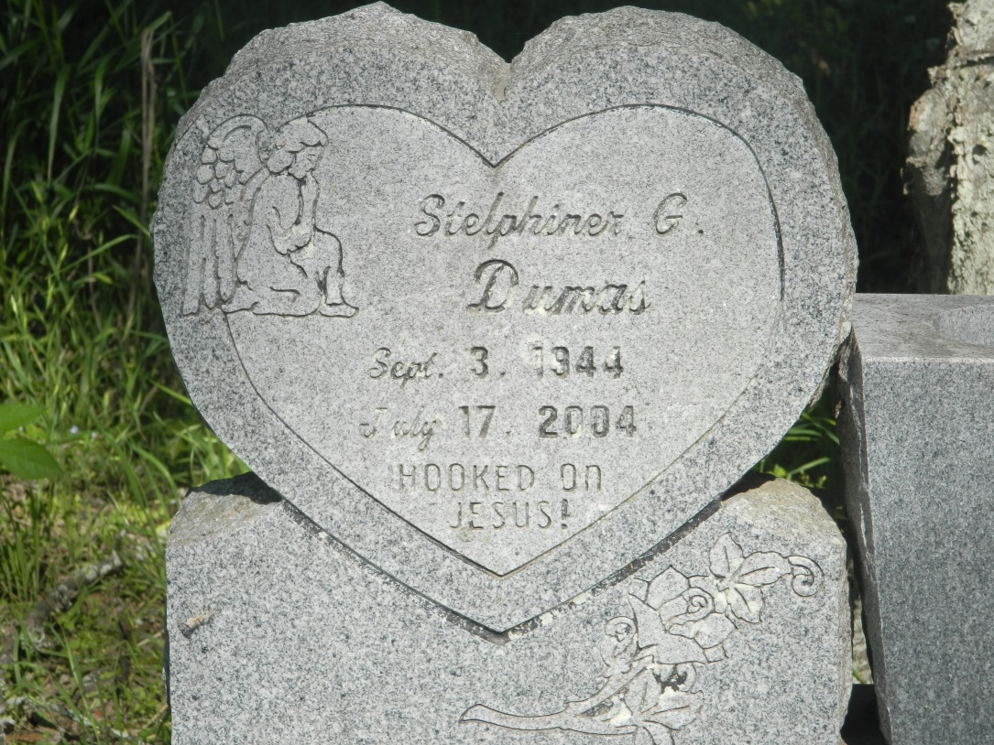

EDGARD - Stelphiner Grows Dumas, 58, a native of Edgard and resident of Wallace, died July 17. She was the wife of Ronald Dumas and mother of Denine and Delicia Dumas.  
  
She was also the sister of Thelma Louis, Mildred Clark, Amy Narcisse, Joseph Jr., Lionel Grows Sr., and the late Hilda Bally, Beulah Bally and Clarence Grows. Services were July 22 at Second African Baptist Church, Edgard, with interment at Willow Grove Cemetery, Wallace.

L'Observateur (La Place, LA) - Friday, July 23, 2004

Contributed by Jane Edson