Elvira (Jones) Holland

1913 – December 4, 1964

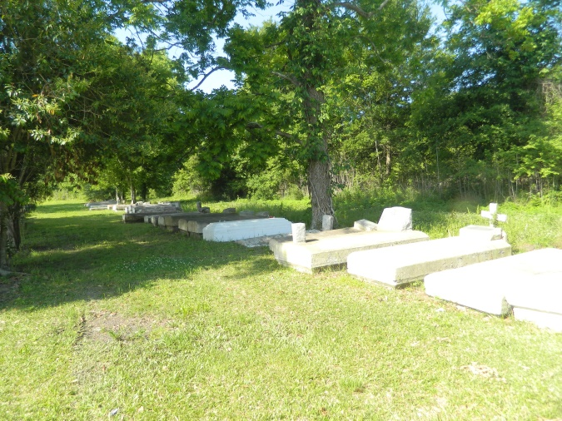

At St. James Parish Hospital, Lutcher, La. On Friday, December 4, 1964, at 6:10 a.m., MRS ELVIRA JONES HALLAND of Mt. Airy, La., beloved wife of Frank Holland; daughter of Mr. and Mrs. Ernest Jones of Wallace, LA; sister of Cora Jones and Mrs. Julia Dumas of Wallace, La., Alvin Jones of New Orleans, La. The deceased is also survived by a host of other relatives and friends; a native of Wallace, La., and a resident of Mt. Airy, La., for many years.

Relatives and friends of the family also pastor, officers and members of St. Marks Baptist Church, St. John the Baptist Church, Mt. Airy, La., Morning Star Baptist Church, and Willow Grove Benevelent Society, Wallace, La., Employes of Godchaux Sugar Refinery. Reserve, La., are invited to attend the funeral. Services from the St. Marks Baptist Church, Mt. Airy, La., on Monday, December 7, 1964, a 12 noon. Rev. Grant Williams officiating. Interment in Willow Grove Cemetery, Wallace, La. Wake services on Sunday night, December 6, 1964, at St. Mark Baptist Church, Mt. Airy, La. Earl Baloney & Sons Mortuary, Garyville, La. in charge.

Unknown source