Cora Jones

1909 – August 6, 1981

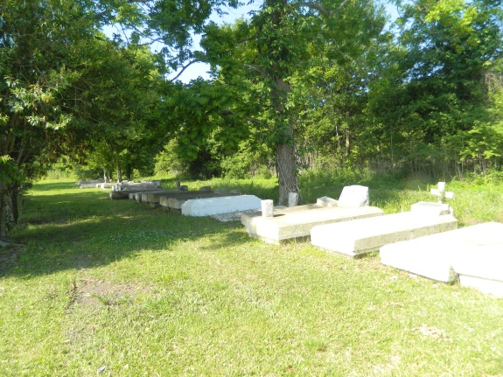

Cora (Sa) (Nanene) Jones, of Wallace, Louisiana, on Thursday, August 6, 1981; daughter of the late Ernest and Bella Jones; beloved sister of Julia Dumas of Wallace, Louisiana, Shirley Ross, Florida Johnson, Willie Rogers of Mt. Airy, Louisiana, Alvin Jones and Philip Rogers of New Orleans, Louisiana, Evelyn Delone of Los Angeles, California and the late Elvira Holland and Lucille Jones; beloved niece of Willis Jones, sister-in-law of Curtis Dumas Sr., devoted aunt of Curtis Jr., Larry, Clifford, Lillian, Ronald Olgamae, Patricia, Ernest, Leo, Clarence, Deborah, and Alania Dumas, and the late Jerry and Harold Dumas; deceased also survived by a host of other nieces, nephews, cousins and friends, a native and resident of Wallace, Louisiana, age 69 years.

Relatives and friends of the family, also pastors, officers and members of the Morning Star Baptist Church, New Jerusalem Baptist Church and all neighboring Churches, James Chapel Baptist Church of New Orleans, Louisiana, Willow Grove Society are invited to attend the funeral Services on Monday August 10, 1981 at 12 o’clock noon from New Jerusalem Baptist Church, Edgard, Louisiana; Reverend F. Johnson officiating. Interment Willow Grove Cemetery. Wake services Sunday August 9, 1981 from the above named Church at 8 o’clock p.m. Visitation after 3 on Sunday. Earl Baloney and Sons Mortuary in charge of arrangements. Carmen M. Baloney, Director.

Unknown source