Rose Mary (Armant) Murray

January 2, 1934 – October 6, 2009

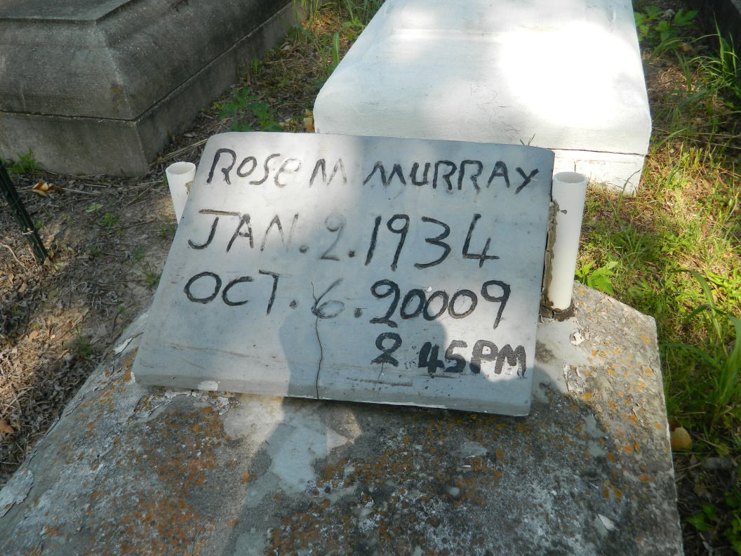

Rosemary Murray on Tuesday, October 6, 2009 at her home in Wallace, LA. Daughter of the late Adolph and Francis Armant. Wife of James Murrey. Mother of Ozeme (Helen) Mitchell III of Waggaman, LA, David Populis, Sr. and Maria Populis both of Wallace, LA and the late Betty Ann Patterson. Sister of Agnes Stieb, Leola Dumas, Wilfred, Morris (Grace), and Charles Armant, the late Emily Howard, Lillian Montgomery, Marie "Eula" Poche, Daisy Ross Poche, Eddie, Gilbert, Norbert and Joseph Armant. Also survived by 14 grandchildren, 16 great grandchildren and a host of nieces, nephews, other relatives and friends. Age 75 years. A native and resident of Wallace, LA.  
  
Relatives and friends of the family, also pastors, officers and members of Morning Star Baptist Church and all neighboring churches and employees of St John the Baptist Parish Utilities, River Parishes Hospital and West Jefferson Medical Center are invited to attend the funeral at Morning Star Baptist Church, 5355 Highway 18, Wallace, LA on Tuesday, October 13, 2009 at 11:00 AM. Rev Frank Johnson, Pastor, Officiating. Interment Willowgrove Cemetery, Wallace, LA. Visitation at the above named church from 10:00 AM until service.  
  
SERVICED BY ROBOTTOM

Times-Picayune, The (New Orleans, LA) - Monday, October 12, 2009

Contributed by Jane Edson