Cornelious Narcisse

April 5, 1939 – October 10, 2007

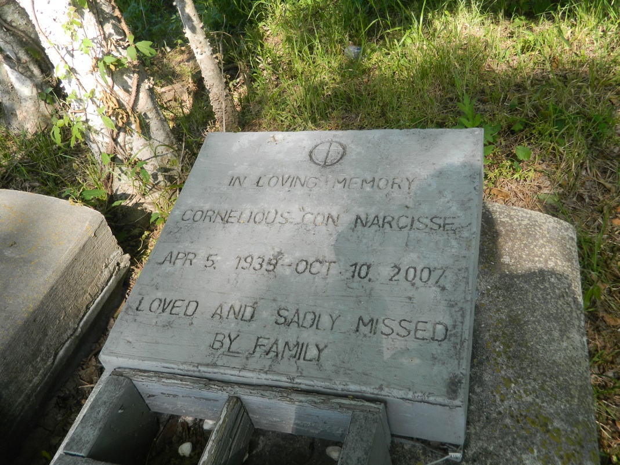

Cornelious (Con) Narcisse, of Edgard, La. at St. James Hospital Lutcher, La. on Wed. Oct. 10, 2007. Son of the late Felician Narcisse and Harriet Dennis Gillard. Husband of Leontine Howard Narcisse. Father of Kenneth (Gwendolyn) Narcisse, Nina (Alton) H. Joseph, Abby Howard. Brother of Alfred (Amy) Narcisse, Marian (Lawrence Sr. ) Grows, Geraldine G. (Julius) Boudoin and the late Junius, Joseph Gillard, Larry and Alvin Narcisse, Delores Slater and Victoria Taylor. Brother-in-law of Ruth Gillard and Eula Mae Narcisse. Also survived by (7) grandchildren (7) great grandchildren other sisters and brothers-in-law, nieces, nephews, cousins other relatives and friends. A native of Vacherie, La. and a resident of Edgard, La. age 68 yrs.  
  
Relatives and friends of the family, also pastor, officers, and members of the Greater New St. Peter B.C. and all neighboring churches. Employees of East Jefferson Hospital, S.S. I., Ramada Inn are invited to attend the funeral services on Mon. Oct. 15, 2007 at 11:00 am from the Greater New St. Peter B.C., West 3rd. St., Edgard, La. Rev. Vernon Alexander officiating. Interment Willow Grove Cemetery Wallace, La. Visitation at the church after 9:00 am on Mon.  
  
The Baloney Funeral Home LLC, 399 Earl Baloney Dr., Garyville, La. 70051, 985-535-2540  
In charge of arrangements

Times-Picayune, The (New Orleans, LA) - Sunday, October 14, 2007

Contributed by Jane Edson