Victor Pablo

October 18, 1991 – February 21, 2021

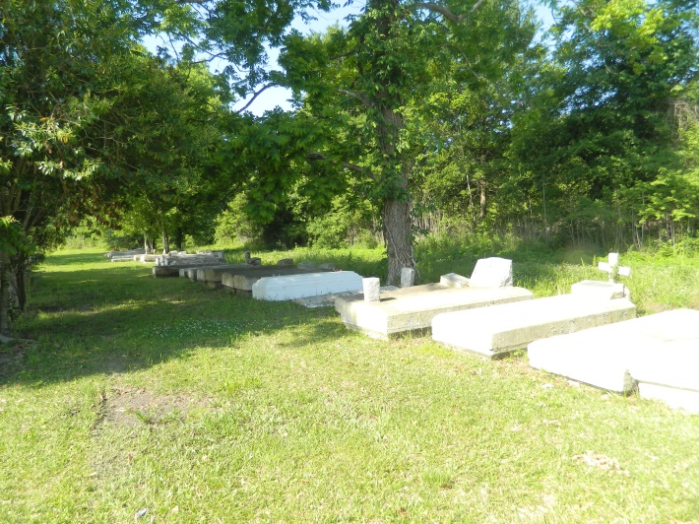

Victor ''Vic'' Pablo transitioned from this life on Sunday, February 21, 2021, at the age of 29. Victor was born in Laplace, La at River Parish Hospital on October 18, 1991 to Elizabeth Pablo. He was the stepson of Victor ''Nolan'' Batiste, who raised him as his own and loved him unconditionally.

Victor was an outgoing young man that loved rap music. He attended Leon Godchaux Adult GED Program in St. John the Baptist Parish School System. On Sunday, February 21, 2021, Victor physically left this earth and a family that loves him very much. He will be missed.

Victor leaves to cherish his memories, his parents, Elizabeth Pablo and Victor Batiste; his son, Chaz Pablo; his siblings, Angela (Patrick), Tyrone (Dominique), Victoria, and Shantell Pablo; one nephew; Jarell Brown; Maternal grandparents; Blanche Pablo and Shelton (Brenda) Valentine, seven uncles, seven aunts, and a host of cousins, relatives, and friends.

A memorial service honoring the life of Victor will be held on Saturday, March 6, 2021 at 11 a.m. at Greater Golden Grove Baptist Church, 127 S. Mulberry Ave., Gramercy, LA 70052. Visitation will be from 9 a.m. until service time. Pastor Jarrow, Officiating. Interment at Willow Grove Beloveth Association, W. 5th St., Vacherie, La. 70090. Visitation will be held on Friday, March 5, 2021, at Bardell Mortuary, 3856 LA-44, Mt. Airy, La. 70076, from 4 p.m.-7 p.m.

Due to the COVID-19 pandemic, seating in the church is limited. Everyone in attendance is required to adhere to all restrictions. You must wear a face mask and practice social distancing. Services entrusted to Bardell's Mortuary. Information: (985) 535-6837.

The Times-Picayune, New Orleans, Louisiana

Mar. 4 to Mar. 6, 2021.