Lorenza "Lo" Poche

June 24, 1945 - June 4, 2022

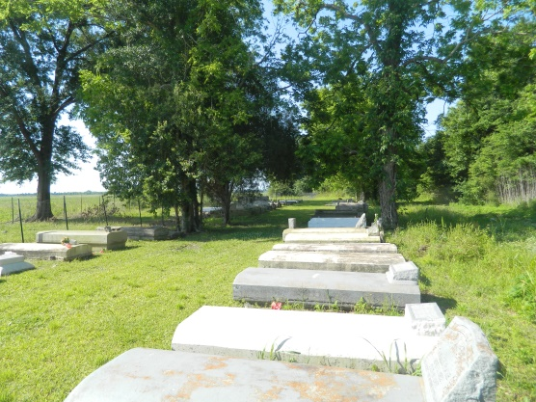

On Saturday, June 4, 2022, at the age of 76, our Lord and personal Savior dispatched His angels to carry Lorenza to her heavenly home, where she was reunited with her loving parents, the late Eugene and Lorenza Poche; one of thirteen children.   
 Lorenza accepted her wings and flew away from this place to her heavenly home. As she laid in her bed, she humbly called on Jesus continuously in a prayer, saying, “Jesus come and get me.”  Yes, she was ready to see her Master’s face. She knew the time of her departure was night. She prepared her only child, Elder Diane, and spoke with boldness her final testimony, “I’m going home, bye, go Diane go, good-bye I love, and appreciate everything you did.” As family members and friends were praying for a miracle, Lorenza was speaking into existence, Psalm 55:6, “And I said, oh that I had wings like a dove! I would fly away and be at rest." Her request to God was granted and her last breath was taken.  
 "Lo" accepted Christ at a very early age and was baptized by the late Rev. Clarence Washington at Morning Star Baptist Church. She later became the church’s secretary for many years, until her health failed. She was very loyal, dedicated, committed, devoted, and passionate as she rendered her services. The love she exemplified for her church and pastor roared an unforgettable memory with lasting impressions.  
 One of her favorite pastimes was to simply surround herself with family and friends; enjoying GOD’s precious creation for fun times. Laughing, joking, eating, cooking, sewing, and her most favorite “Telling folks what is on her mind” is some of the unforgettable memories Lorenza has blessed the world with. Ultimately, all of her characteristics exude an abundance of love and care for everyone she met. The undying love committed to helping others in need; especially in children, was a great expression she shared.  
 The weekly grocery store runs, were always focused on snacks and food for here great-grandchildren and/or “the cherin in the bac”. Her passion for cooking every single day; warmth “Willow Grove” as she always shared meals—due to her never eating “left-over”. Diane was her go to person for shopping for sales on the weekend and spending quality time with her mother. Family and friends could rely on her for cleaning, washing, sewing and other domestic needs; as she enjoyed making things spotless. “A clean up woman, that’s who she was”.  
 Lorenza leaves to cherish her memories, her loving and caring daughter: Diane (Bobby) Robertson of Vacherie, La.; grandchildren: Bobby (Nikita) Poche and Brad (Gabrielle) Robertson; six great-grandchildren: Brayden, Bentley, Braxton and Gianna Robertson, and Cole and Reese Poche; four sisters: Isabella Poche, Clementine Gros, Geraldine Gray, and Dorothy Glapion; and one Godchild: Brian Gordon. She also leaves a host of nieces, nephews, cousins, other relatives, and friends.  
 Lorenza was preceded in death by her parents, Eugene and Lorenza Poche; and siblings, Celeste P. Oubre, Catherine P. Theard, Camille, Roy, Curtis, Clement, Eugene, and Harold Poche.   
 Relatives and friends of the family are invited to attend the home-going services on Saturday, June 11, 2022, at Morning Star Baptist Church, 5355 LA-18, Vacherie, LA 70090. Visitation will begin at 9am until services begin at 11am. Pastor Frank Johnson officiating. Interment to follow at Willow Grove Cemetery on W 5th St. Final care and professional services entrusted to Treasures of Life Funeral Services, 315 E. Airline Hwy., Gramercy, LA 70052.

Treasures of Life Funeral Services, Gramercy, LA

August 15, 2022