Scott Patrick Poche

February 10, 1966 – October 19, 2006

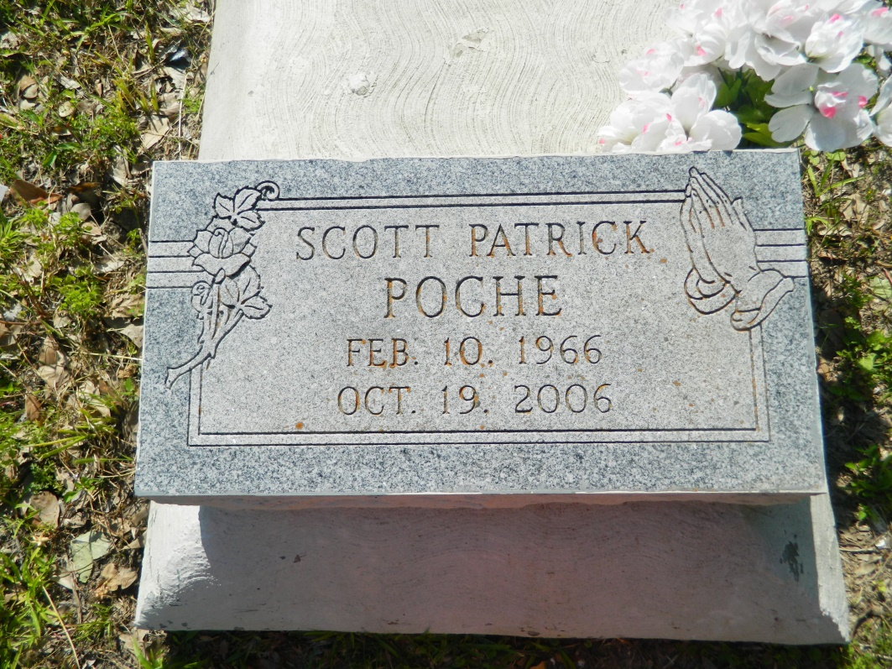

Scott Patrick "Big Cup" Poche passed away on Thursday, October 19, 2006 at Embracing Hospice Center in Atlanta, Georgia. Beloved son of Margaret Steib Smith and the late Harold Poche, Sr. Step-son of Charles Smith. Former husband of Marjanet Wilson. Brother of Ada James (Roy) of Garyville, LA, Deidra Pierce (Jason) of Edgard, LA and Harold Poche of Fort Worth, Texas. Step-children: Julice Ford of Baltimore, Maryland and Jamelia Ford of Atlanta, Georgia. Uncle of Carvente, Jayton, Damond, Jaylan and Callie. Also survived by a host of aunts, uncles, cousins and friends. A native of Wallace, Louisiana and a resident of Atlanta, Georgia for the past 11 years. Age 40.  
  
Relatives and friends; members of Morning Star Missionary Baptist Church, St. John the Baptist Catholic Church, all neighboring churches and West St. John High Class of '85 are invited to attend Funeral Services to be held on Wednesday, October 25, 2006 at Morning Star Missionary Baptist Church at 11:00 a.m. Visitation will begin at 8:00 a.m. until funeral service. Rev. Frank Johnson, officiating. Inerment Willow Grove Cemetery, Wallace, LA.  
  
Arrangements by D.W. RHODES FUNERAL HOME, 1020 Virgil St., Gretna, LA.

Times-Picayune, The (New Orleans, LA) - Tuesday, October 24, 2006

Contributed by Jane Edson