Bernard Ross Sr.

Abt. 1953 – July 18, 2004

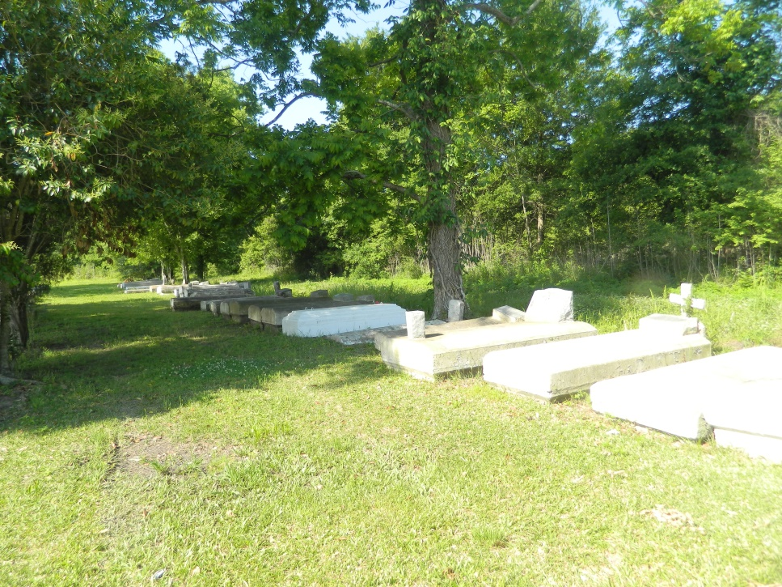

EDGARD – Bernard Ross Sr., 51, a native and resident of Wallace, died July 18. He was the husband of Kay Ann Ross, father of Shakema and Bernard Ross Jr., and stepfather of Zara and Crystal Stipe.

He was also the son of Shirley Ross Gibson, and the late John Gibson, and brother of Albert Craig Jr., John Gibson III, Bernadette Bardoin and Cheryl Dodd. He is also survived by 10 grandchildren.

Services were July 22 at New Jerusalem Baptist Church, Edgard, with interment at Willow Grove Cemetery, Wallace.

L’Observateur, LaPlace, Louisiana

Friday, July 23, 2004