Wilfred Armant Sr.

June 17, 1924 – August 2, 2010

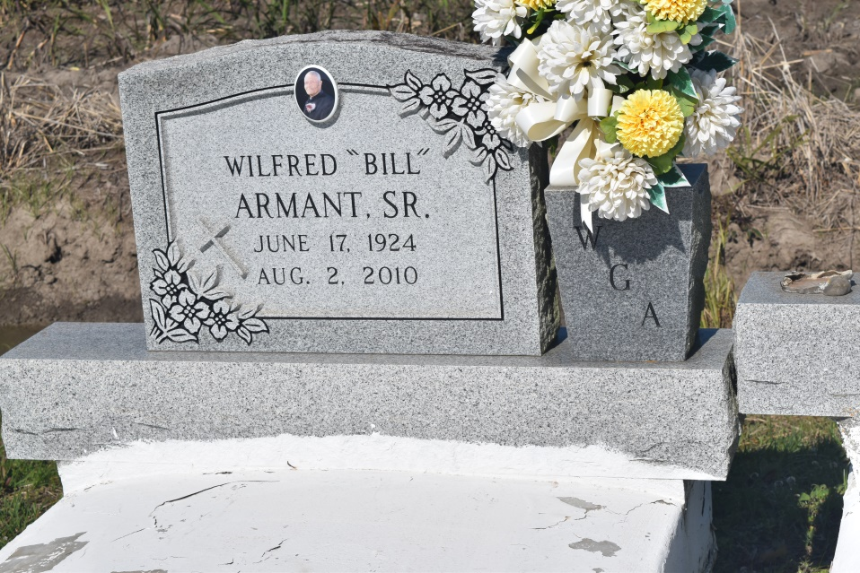

Gravier Wilfred (Bill) Armant of Wallace, La., at his residence, on Mon., Aug. 2, 2010 departed this life. Son of the late Adolph and Francis Allen Armant. Beloved husband of the late Elvira Bradley Armant. Father of Ellenor, Rickey, Gregory, and Melinda Armant of Wallace, La., Darleen and Alton Armant of New Orleans, La., Veronica Griffin (Troy) of LaPlace, La. and the late Wilfred Armant Jr. (Rosemary). Brother of Leola Dumas, Vacherie, La., Morris Armant (Grace), St. Rose, La., Charles Armant, Sr., Wallace, La., and the late Emily Howard, Rosemary Murray, Lillian Montgomery, Agnes Steib, Marce "Eula" Poche, Daisy Ross Poche, Norbert, Eddie, Gilbert, and Joseph Armant. Also survived by 8 grandchildren, 11 great-grandchildren, 1 sister-in-law, 4 godchildren, a host of nieces, nephews, cousins, other relatives and friends. A native and resident of Wallace, La. Age 86 years.  
  
Relatives and friends of the family, also priest and parishioners of St. Philip Catholic Church, Greater Woodville B.C., St. Leo the Great Catholic Church, Living Way United Pentacostal Church and neighboring churches, employees of Northrop Grumman F/K/A Avondale Shipyards, Broadmoor LLC and Concern Care Hospice are invited to attend the funeral services on Fri., Aug. 6, 2010 at 11:00 AM from St. Philip Catholic Church, Vacherie, La. Father Christopher Decker, celebrant. Interment: The Greater Woodville B.C., Wallace, La. Visitation at the church after 8:30 AM.  
  
The Baloney Funeral Home LLC, 399 Earl Baloney Dr., Garyville, La.; 985-535-2540

**Times-Picayune, The (New Orleans, LA) - Thursday, August 5, 2010**

**Contributed by Jane Edson**