Nathan Bradley

June 23, 1930 – December 19, 2007

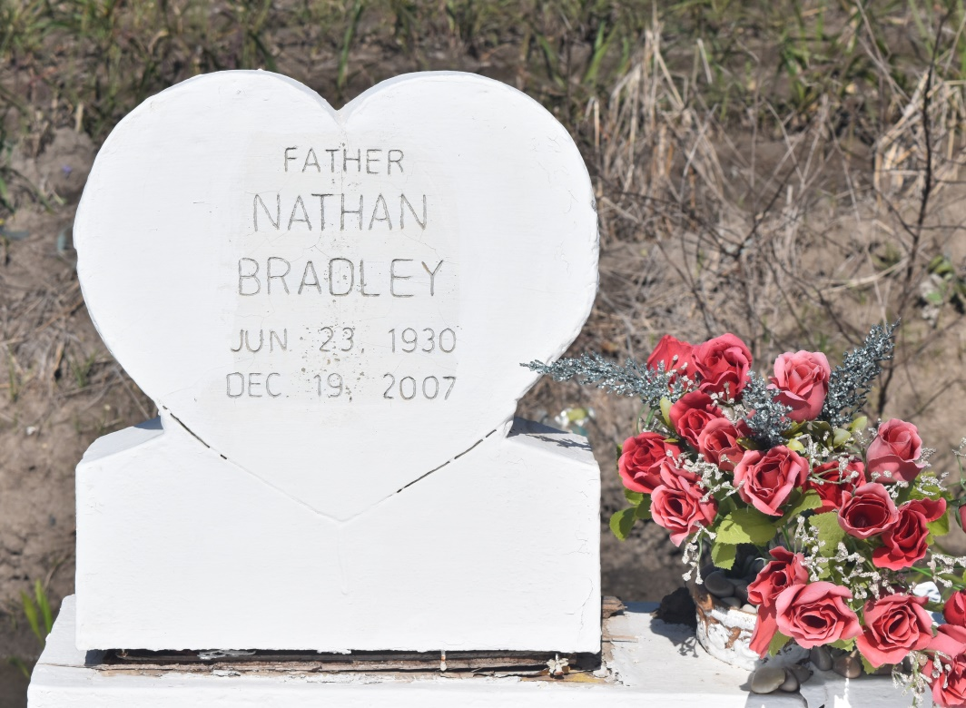

Nathan (Blue) Bradley at his residence in Vacherie, La. on Wed., Dec. 19, 2007 departed this earthly life. Son of the late Samuel and Elvira Mitchell Bradley. Husband of the late Leana L. Bradley. Devoted companion of Edwina Lewis. Father of Joyce Savoie (Craig), of Edgard, La. and the late Dale Arnold Bradley. Also survived by grandchildren and great grandchildren. Brother of Elvira B. Armant (Wilfred), and the late Rosemary B. Gordon, Cecelia B. Calvin, Annie Mae B. Jackson, Haywood, Samuel, and Melvin Bradley Sr. Survived by a host of nieces, nephews, other relatives and friends. A native of Wallace, La. and a resident of New Orleans, La. before moving back to Vacherie, La. Age 77 years.  
  
Relatives and friends of the family, also Pastor, officers, and members of the Greater Woodville, B.C. and neighboring churches are invited to attend the funeral services on Sat., Dec. 22, 2007 at 10:00am from the Greater Woodville B.C., W.9th St., Wallace, La. Rev. Mark Nelson officiating. Interment church cemetery. Visitation at the church after 9:00am. Final viewing before services begin.  
  
The Baloney Funeral Home LLC, 399 Earl Baloney Dr. Garyville, LA. 70051; 985-535-2540;   
In charge of arrangements.

**Times-Picayune, The (New Orleans, LA) - Friday, December 21, 2007**

**Contributed by Jane Edson**