Henry Clay

November 25, 1945 – June 29, 2007

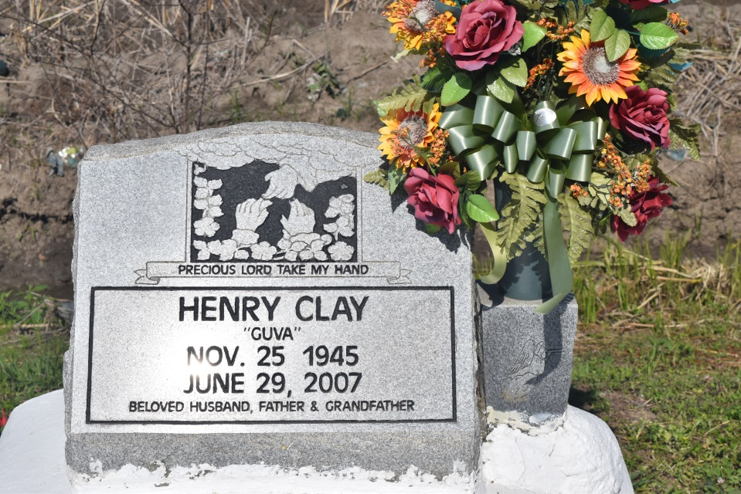

Henry (Govia) Clay, a native and resident of Wallace, LA, died Friday, June 29, 2007. Former husband of Phyllis Clay. Father of Sirena , Henry Jr., Andray and Nicole Clay, Elizabeth and Henry Tillman, Alba and Althea Thompson. The stepfather of Clarence and Marionne Tillman. The son of the late Annie Mae Bradley Clay Jackson and Harold Clay, Sr. The brother of Ethel Young, Marie, Bienville Jr. and Albert Jackson and the late Harold Clay, Jr. Henry ws reared by the late Rosemary and Wilbert Gordon, Sr., along with their children: Lucille Soraparu, Verna Clofer, Sheryl Johnson, Kren, Willa, Patricia and Dale Gordon. Grandfather of Shelby Fallen of Wallace, LA. Also survived by 10 grandchildren, a host of nieces, nephews, cousins, other relatives and friends. A native of Wallace, LA. Age 71 years.  
  
Relatives and friends of the family; also pastors, officers and members of Greater Woodville B.C., 133 W. 9th St., Wallace, LA are invited to attend the Funeral Services on Thursday, July 5, 2007 at 11:00 a.m. from the Greater Woodville B.C., W. 9th St., Wallace, LA., Rev. Marc Nelson, officiating. Visitation at the Church after 8:00 a.m. Interment Church Cemetery. Final viewing before services begin.  
  
THE BALONEY FUNERAL HOME, L.L.C., 399 Earl Baloney Dr., Garyville, LA 70051  
Information: (985) 535-2540; IN CHARGE OF ARRANGEMENTS

**Times-Picayune, The (New Orleans, LA) - Wednesday, July 4, 2007**

**Contributed by Jane Edson**