Augustine (Grant) Davis

April 20, 1936 – August 24 2010

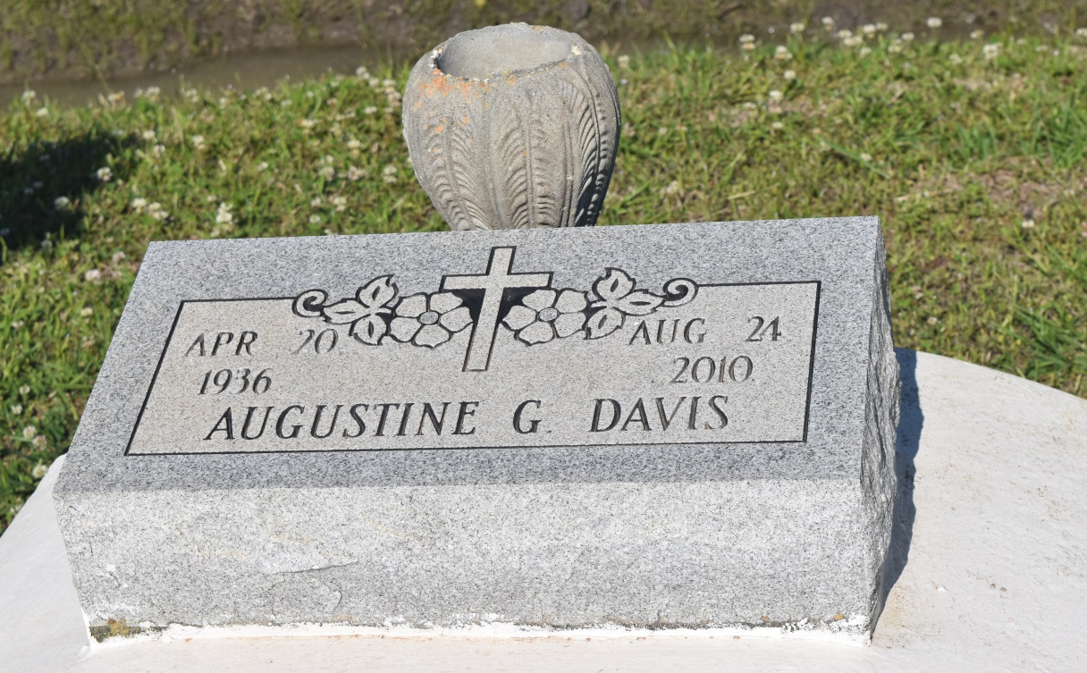

Augustine Grant Davis at Riverlands Health Care Center in Lutcher, LA, at 9:45 P.M., Monday, August 23, 2010. Daughter of the late Rev. Wilkerson Grant and Wilberine Mary Armont Grant. Wife of the late Wilmer Davis, II. Mother of Wilmer Davis, III. Step-mother of Cortez Brooks and Derrick Robinson. Sister of the late Ruby Ann Grant, Ethel Anderson and Alfred Grant, Sr. Foster sister of Jenny Cooper, Rosetta Lirette, Dorothy Elder, Diane Wilson, Geneva Lucas and the late Beulah Lirette. Devoted aunt of Charlotte Ann Grant. Sister-in-law of Carolyn Grant. Also survived by numerous nieces, nephews, cousins, other relatives and friends. Age 74.  
  
Relatives and friends of the family, also Pastor, Officers and Members of Greater Woodville B.C., and all neighboring churches, U.S. Army of Slidell Recruiting Station, and Riverland Health Care Center are invited to attend the Homegoing Celebration on Thursday, August 26, 2010 at Greater Woodville B.C., 193 West 9th Street, Wallace, LA, with viewing beginning at 9:30 A.M. until Services at 11:00 A.M. Conducted by the Rev. Marc Nelson. Interment in church cemetery. Viewing prior to Funeral Services only.  
  
Brazier-Watson Funeral Home in charge of arrangements.

**Times-Picayune, The (New Orleans, LA) - Wednesday, August 25, 2010**

**Contributed by Jane Edson**