Raymond Draten, Sr.

Abt. 1955 – September 8, 2019

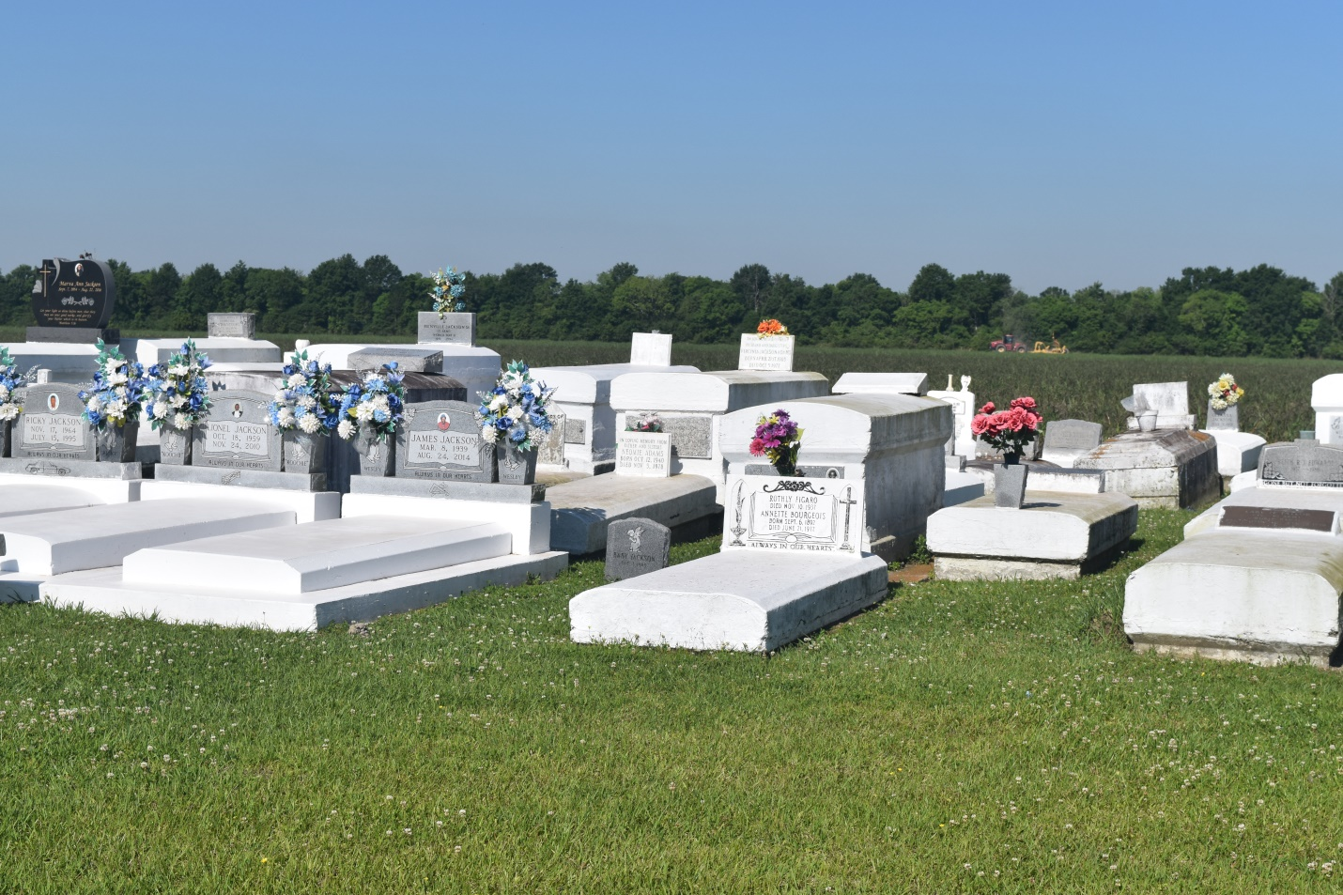

Raymond "Butsy" Draten, Sr., a native of Wallace, LA and resident of Edgard, LA, departed this earthly life on Sunday, September 8, 2019 at Tulane Medical Center surrounded by his loving family at the age of 64.

Left to cherish his memory are his devoted wife of 26 years, Wanda Young Draten; children, Taryn Young, Raymond Draten, Jr., and Kylan Draten; grandchildren, Noel and Isaiah Draten; sisters, Linda Draten and Katherine Draten; mother-in-law, Myrtis Young; sisters-in-law, Jacqueline (Clarence) Sorapuru, Barbara (Byron) Bernard, and Stacy Draten; brother-in-law, Freddie (Nakeela) Young Jr.; and a host of nieces, nephews, cousins, other relatives, and friends. Raymond is preceded in death by his parents, Arthur Draten and Geraldine Rheams Draten, brother Troy Draten Sr., and father-in-law Freddie Young, Sr.

Relatives and friends, members of Morning Star Missionary Baptist Church, and all neighboring communities and churches are invited to attend a Homegoing Celebration at Morning Star Missionary Baptist Church, 5355 Highway 18, Wallace, LA 70090 on Saturday, September 21, 2019 at 10:00 a.m., Reverend Frank Johnson, Th.D. officiating. Visitation will be held from 8:00 a.m. until the time of service. Interment at Woodville Cemetery, Wallace, LA 70090.

Final care entrusted to Bardell's Mortuary, 3856 Highway 44, Mount Airy, LA 70076.

Published in The Times-Picayune (New Orleans, LA) on Sept. 21, 2019