Sgt. Joseph W. DuPart

September 25, 1925 – September 19, 1950

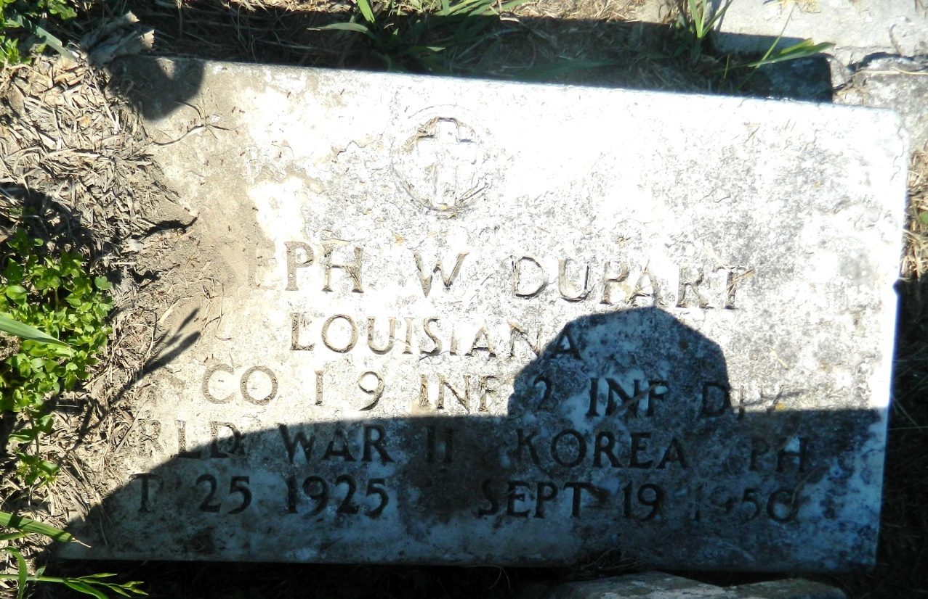

TWO LOUISIANIANS KILLED IN ACTION

Washington, Oct. 27 – (AP) – Two Louisianians killed in action in the Korean area were listed today by the department of defense in its 135th casualty lists.

Corp. Austin J. Anderson, son of Mrs. Enoice Anderson, 301 Mathilda Ave., Eunice.

Sgt. Joseph W. DuPart, son of Mrs. Mary Lee DuPart, 213 Jackson Ave., New Orleans.

**The Monroe News-Star (Monroe, Louisiana) · 27 Oct 1950, Fri · Page 8**

**Downloaded on Apr 27, 2018 from Newspapers.com**