Vivian (Jackson) Dumas

January 4, 1921 – September 14, 2013

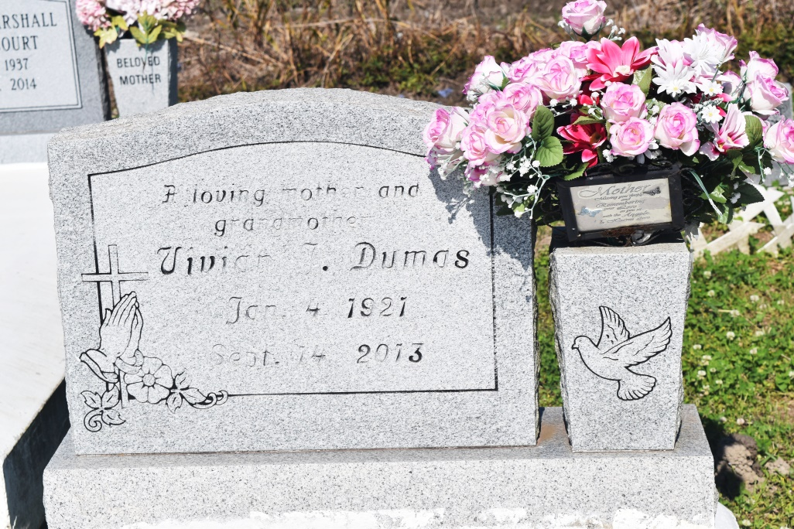

Vivian "Gammie" Jackson Dumas, a retired employee of Eye, Ear, Nose and Throat Hospital in New Orleans, LA where she worked for 26 years, died Saturday, Sept. 14, 2013 at her residence in Denham Springs, LA. She was 92, and a native of Vacherie, LA. Visiting at Franklin Avenue Baptist Church, 10915 Florida Blvd. Baton Rouge, LA (housed in Florida Blvd. Baptist Church), from 10 a.m. to Religious Services at 11 am Saturday, Sept. 21, 2013 officiated by Rev. Manuel Piggee, III. Burial in Woodlawn Cemetery in Wallace, LA.

Survived by 2 daughters, Helena Dumas McClue (Bruce), and Barbara Dumas Haynes, all of Walker, LA; 1 son, Ernest Dumas, Jr. (Ester) of New Orleans, LA; A sister-in-law, Marion Dumas Williams of Augusta, GA; Also 8 grandchildren, 16 great grandchildren, 3 great great grandchildren, and a host of step great grandchildren, nieces, nephews, other relatives and friends. Preceded in death by her husband, Ernest Paul Dumas, Sr.; parents, Moses and Mary Favorite Jackson; 3 brothers, Bienville, Frank, and Melvin Jackson; 2 sisters, Helena Jackson, and Mildred Jackson Florent. In lieu of flowers, donations can be made to Accent's Attendant Care, lnc., 9403 Huntington Drive, Denham Springs, LA 70726.

Arrangements by Williams & Southall Funeral Home, Napoleonville, LA (985) 369-7231. To sign guest book or offer condolences, visit our website at [www.williamsandsouthallfuneralhome.com](http://www.williamsandsouthallfuneralhome.com).

**Advocate, The (Baton Rouge, LA) - Thursday, September 19, 2013**

**Contributed by Jane Edson**