Eddie Edwards, Jr.

February 24, 1936 – March 20, 2016

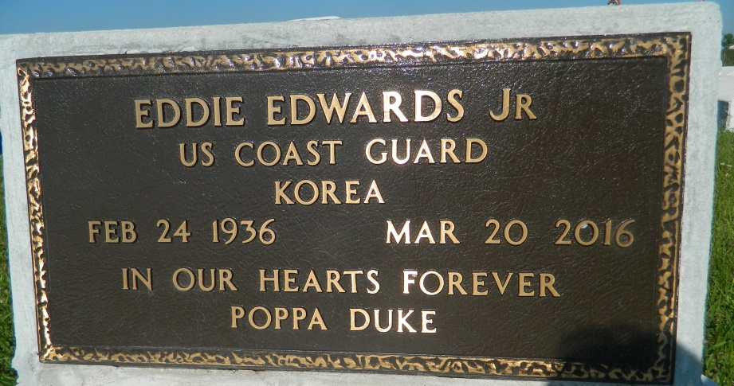

Legendary jazz musician, Eddie "Poppa Duke" Edwards, Jr., entered into eternal rest on Sunday, March 20, 2016 at his home in New Orleans, LA. Born into a Creole family filled with generations of jazz musicians, he began his personal musical career in the US. Coast Guard's Drum and Bugle Corps. Following his tenor at Berklee College of Music, Boston, MA, he traveled to Montreal Canada where joined jazz musician Sun Ra and his orchestra, studying composition and harmony. He was introduced to booking agent, Rob Scribner and together, they formed Music Canada, where he created, produced wrote music, groomed, managed and worked with some of the finest musical talent in Toronto, Canada. Eddie “Poppa Duke” Edwards was a renowned recording artist who performed in prestigious venues such as Carnegie Hall, and Madison Square Garden. In 1972, Eddie “Poppa Duke” Edwards retired from the music industry and created a traveling communal group called the "Mud People", which was made up of university professors, an attorney, and a doctor. They traveled to the banks of the Mississippi River in the parish of St. John in the town of Wallace, La. to work in the community with the objective to create better race relations between people of all races while teaching universal brotherhood, New Orleans Jazz.  
 Eddie "Poppa Duke" leaves to cherish his memories, four children, Desiree Edwards, Renee Edwards Joyner, Masai Edwards and Yishmene Edwards; his third wife Evelyn Edwards; 11 grandchildren and 11 great grandchildren. He is predeceased by two wives, Theresa Mary Clay Edwards and Jean Smith Edwards, his father Eddie Edwards, Sr., mother Melpauliner Jackson Edwards Bastian, son Kieth Edwards, and grandson Kiilu Edwards.  
 A celebration of life will be held on April 1, 2016 at West St. John High School, 480 Highway 3127, EDGARD, LA. Visitation begins at 9:00 am followed by service at 11:00 am. Interment Woodville Cemetery LA 3213, Wallace, LA. Treasures of Life-Center for Life Funeral Services entrusted with his final care. "When someone you love becomes a memory, that memory becomes a TREASURE!"

**Downloaded from obittree.com on 4/28/2018**