Erroll Gene Edwards

February 24, 1951 – April 28, 2002

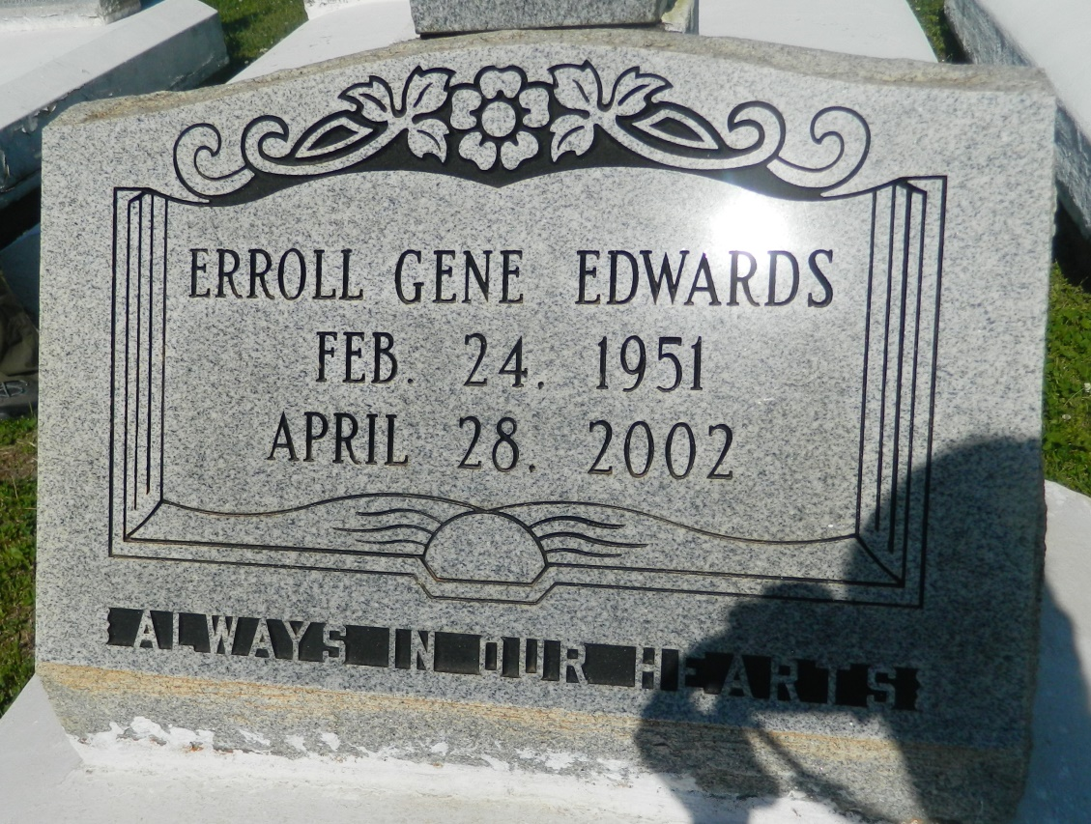

WALLACE - Erroll Gene "Geno" Edwards, 51, a native of Killona and resident of Chicago, died April 28. He was the son of the late Pierre Sr. and Audrey Gaudet Scott and brother of Gaynell, Shawn, Lisa, Kenneth, Pierre Jr., Tyronne, Danna and the late Dale and Stacey Edwards.  
  
Services were May 6 at Greater Woodville Baptist Church, Wallace, with interment at the church cemetery.

**L'Observateur (La Place, LA) - Monday, May 13, 2002**

**Contributed by Jane Edson**