Charles Gaudin

December 13, 1935 – July 9, 1951

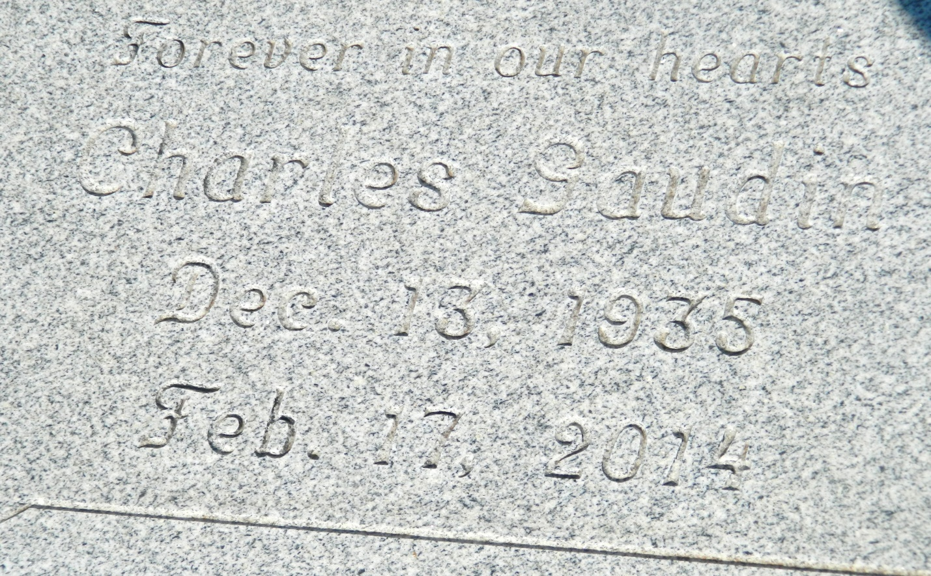

Charles Gaudin

He died Mon., Feb. 17, 2014 at Chateau St. James Nursing Center in Lutcher, LA. He was 78, a native of Wallace, LA and a resident of Lutcher, LA. Visiting at First Community Antioch Baptist Church, 10860 Hwy 3125, Lutcher, from 9 am until religious services at 11am Saturday, Feb. 22, 2014 Pastor Ferdinand Gaines, Jr. officiating. Burial at Woodville Baptist cemetery, Wallace, LA. Arrangements by Williams & Southall Funeral Home, 5414 Hwy 1, Napoleonville, LA (985) 369-7231. To sign the guest book or offer condolences, visit [www.williamsandsouthallfuneralhome.com](http://www.williamsandsouthallfuneralhome.com).

**Advocate, The (Baton Rouge, LA) - Thursday, February 20, 2014**

**Contributed by Jane Edson**